TO: mdrs-reports.gp@marssociety.org
CC: zafa277fusi@post.wordpress.com
SUBJECT: Crew 186 Science Report Navigation 13Jan2018

[title Science Report – January 13th]
[status draft]
[category science-report]

The Effectiveness of Radio Direction Finding for EVA Navigation in Situations of Low Visibility
Justin Mansell
MDRS Crew 186 Journalist

Motivation
Determining one’s position is a fundamental problem encountered in engineering. On Earth it is possible to use the constellation of GPS satellites to accurately pinpoint your position relative to a location where you would like to go. This capability does not currently exist on Mars, nor will it be likely to exist when humans first set foot on the planet. The difficulty of localizing an astronaut’s position relative to a location of interest is amplified in conditions of low visibility such as night or an unexpected dust storm. The resulting disorientation could greatly imperil any astronaut caught unprepared in such circumstances.

The purpose of this research was to explore how a disoriented astronaut might use radio signals to guide them to a target while on EVA. The core concept is to have the astronaut carry a radio antenna whose sensitivity is directional. Meanwhile, a navigation beacon at the target broadcasts a radio signal in all directions. If the astronaut is unable to locate their query by traditional means they can use the directional radio to determine the direction of the transmitting beacon, and therefore the direction they must walk to reach it.

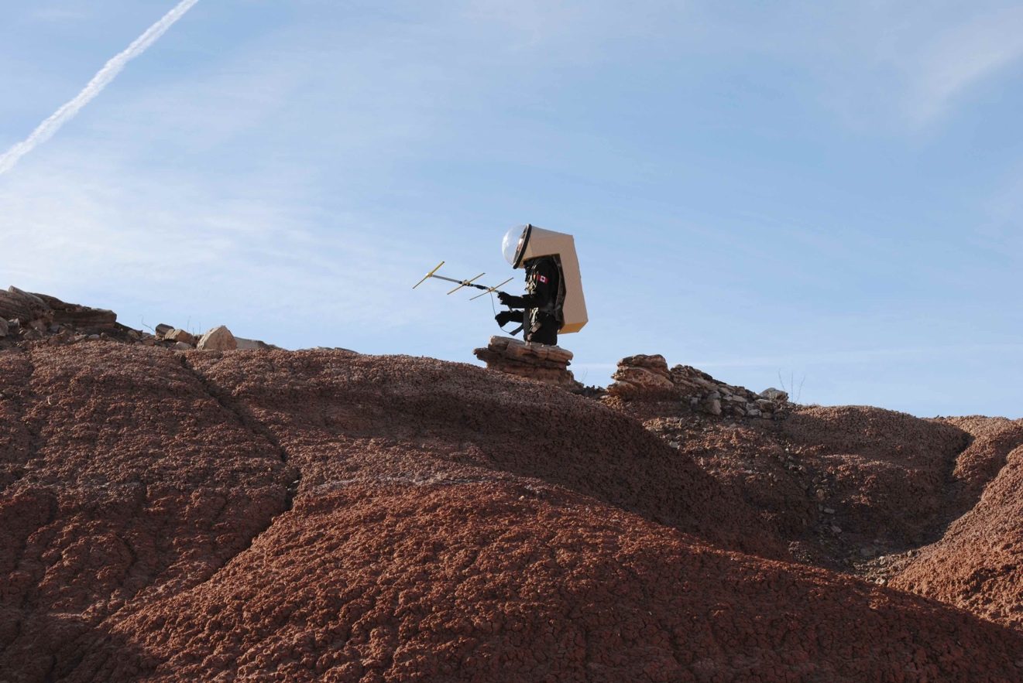
Figure 1: Searching for the direction of maximum signal.

Experiment Setup
Prior to the mission I assembled a 3-element handheld Yagi antenna from schematics researched on the Internet. The particular design uses foldable elements made from steel tape measure and originated with Joe Leggio for use in amateur radio foxhunts [Leggio, 1993]. This design is lightweight and easy to stow due to the foldable elements. A coaxial cable with an SMA adapter allows the antenna to be plugged into virtually any portable ham radio.

The transmitter beacon is a commercial handheld ham radio with no special modifications. I created an audio file of a Morse signal toning the phrase, “This is the MDRS amateur navigation beacon crew 186”, and broadcast this signal from the beacon by connecting an iPod playing the audio file to the radio with an aux cable. In each test of the navigation experiment the radio beacon was located at the habitat and the Morse signal was broadcast at regular intervals by having a crewmember simply hold down the transmit button. A crewmember on EVA would then attempt to use the Yagi antenna to locate the direction of maximum signal and thereby the bearing to the habitat. The beacon was transmitted on the low power setting of the beacon radio (approximately 2.5 Watts) at a frequency of 146.565 MHz.

The Yagi antenna was used to aid EVA navigation on a total of four EVA’s, two of which were dedicated exclusively to testing its effectiveness. On the first two tests I followed a road on the outward trek and then attempted to follow the navigation signal along a straight line back to the habitat. This took me through unfamiliar terrain but did not adequately represent conditions of low visibility. On the later two tests I gave the antenna to a crewmember unfamiliar with amateur radio and covered the upper two thirds of their helmet with a cardboard visor. This restricted their vision to approximately 5 meters and prevented them from using landmarks to help them locate the habitat. Supporting members of the EVA then led the “lost astronaut” volunteer at least 2 kilometers from the habitat and monitored their safety as they attempted to return to the habitat using the radio alone.

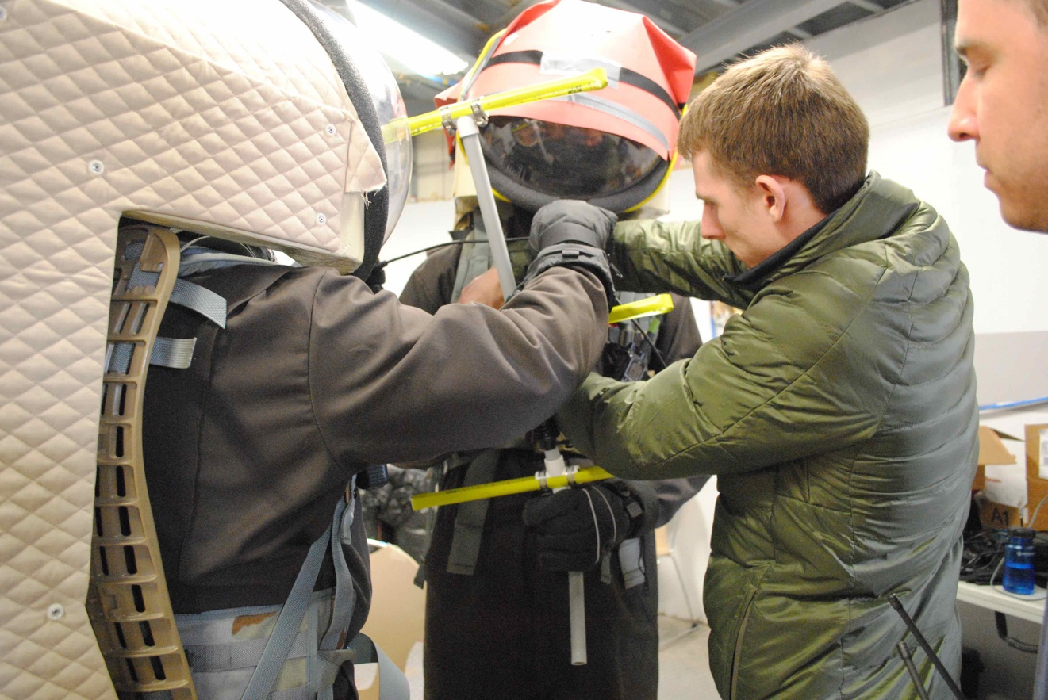
Figure 2: Preparing the lost astronaut before EVA.
Results
The first two tests of the navigation antenna were useful for understanding its performance. The accuracy of the antenna in locating the direction to the beacon generally improves with distance. This is because close to the beacon the signal is strong enough to saturate the receiver even along its insensitive axis. The beacon signal therefore appears to originate from all directions. At greater distances the beacon signal is weak and careful pointing of the antenna may be required to receive it at all. At a distance of 4 kilometers the accuracy of the antenna in determining the bearing to the habitat appeared to be better than 10 degrees. This was reduced to over 90 degrees when within a kilometer of the habitat and worse still when even nearer.

During the tests I found that the poor accuracy of the antenna near the transmitter could be mitigated in the following way. The antenna is least sensitive to incoming signal along a direction parallel to the receiving elements. By searching instead for the direction of minimum signal I could deduce that the beacon was located at a right angle to my current pointing direction. This provided acceptable accuracy at sub-kilometer distances.

On the tests with the cardboard visor limiting the astronaut’s vision the difficulty of navigating by natural senses alone was professed by the arcing paths participants took prior to and in between broadcasts of the navigation beacon. In fact, on the final test the mock “lost astronaut” walked a complete circle with a radius less than 100 m in between two broadcasts of the beacon. To limit the drift of the astronaut’s path it was necessary to decrease the intervals between the beacon transmissions to a nearly continuous broadcast. In both tests with the cardboard visor the astronaut was able successfully navigate to within 500 meters of the habitat despite limited knowledge of their initial position and orientation.

I also note that the surrounding terrain did not appear to have a significant detrimental affect of the performance of the antenna, but this has been difficult to quantify.

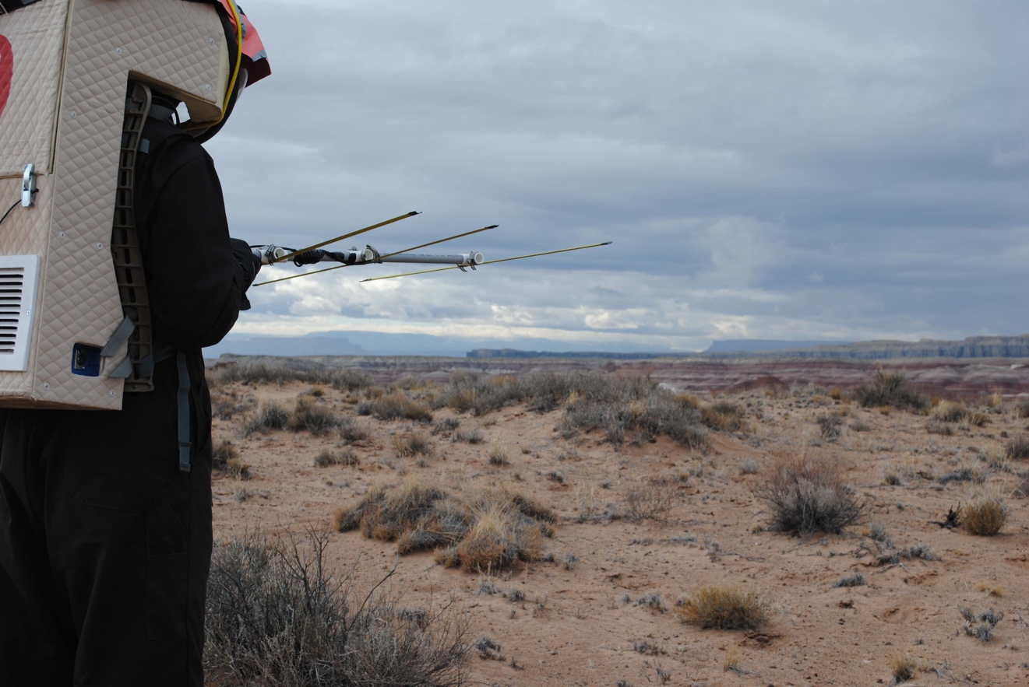
Figure 3: Scanning to find the bearing to the hab.
Recommendations
The navigation experiments of MDRS Crew 186 suggest that a handheld directional antenna is a simple and effective means of EVA navigation in low visibility conditions. However, the current set up has several limitations which are noted below.

The current means of searching for the direction of maximum signal provides only the direct bearing to the transmitter beacon. As was found in several of the tests, following a direct path to the beacon is not always possible due to intervening terrain. The user is then on their own to determine an appropriate detour and this may act to further their disorientation. Additional information may be required beyond that provided by a directional antenna in order to navigate successfully.

At distances close to the transmitter the technique of searching for a direction at right angles to the directions of minimum signal proved satisfactory in our experiments. However, because there are always two such directions the astronaut is at risk of following a path directly away from the beacon instead of towards it. This is possible when receiving along the sensitive axis of the antenna as well, but is less likely because the signal strength received by the back lobe of the antenna is generally much weaker compared to the front. Instead of searching for the direction of minimum signal, a better solution would be to attach an attenuator between the antenna and receiver so that the astronaut can reduce the received signal when close to the beacon.

Finally, the rapid drift of participants from their initial heading in between broadcasts of the beacon suggests that either the navigation beacon should be broadcast continuously or astronauts should have some way of preserving their orientation while walking. The later option is desirable because terrain, weather, or the need to handle equipment may temporarily prevent the signal from being received. On Earth an obvious solution is to mark the desired bearing on a compass and follow it accordingly, but this will not work on Mars due to the lack of a global magnetic field.

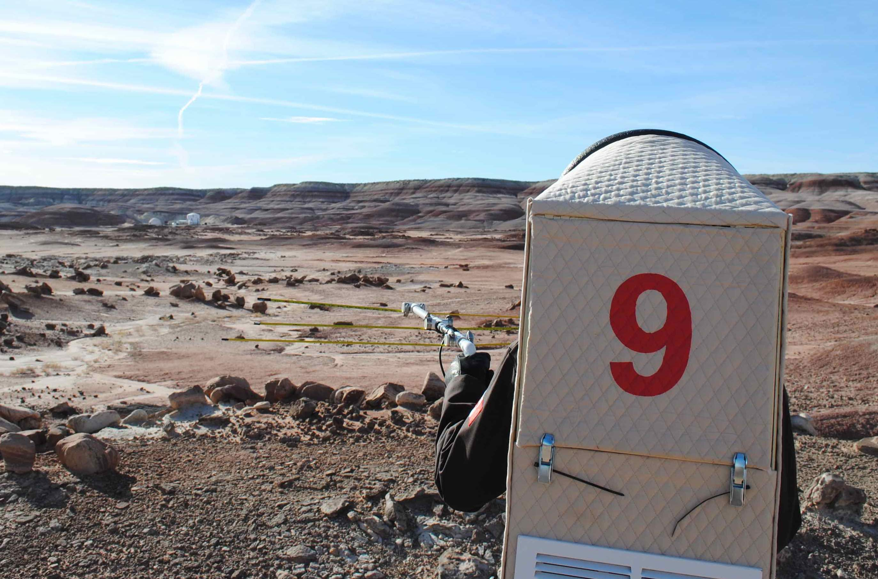
Figure 4: Finding the habitat using its radio beacon.

Bibliography
Leggios, J. (1993), Tape Measure Beam Optimized for Radio Direction Finding, http://theleggios.net/wb2hol/projects/rdf/tape_bm.htm.

Acknowledgements
I would like to thank Geoffrey Andrews, Jennifer Pouplin, and Cesare Guariniello at Purdue University for their assistance fabricating and testing the Yagi antenna prior to the mission.

[end]

