**Lindsay Rutter, Crew Commander**

Lindsay Rutter is a JSPS postdoctoral fellow at the University of Tsukuba. She studied bioinformatics and statistics during her doctoral training, interning as a software engineer, data visualization analyst, and computational biologist at several institutions. She now applies these quantitative skills toward astrobiology and space life science projects, primarily studying biological data from the International Space Station.

Lindsay is a co-founder and co-chair of International Standards for Space Omics Processing, a member of NASA GeneLab analysis working group, and an affiliate member of NASA Network for Life Detection. She believes investigating whether life exists beyond Earth could prompt some of the most profound philosophical discoveries about humanity's relation to the universe. During the mission, Lindsay will use a handheld DNA sequencer to test human operations of life detection on Mars. Her participation is supported by an Emerging Space Leader Scholarship from the Mars Society.

Lindsay loves exploring new horizons: she recently earned a Ham Radio license and, on Halloween Eve, she jumped out of a plane dressed as (an uncharacteristically frightened) Wonder Woman. She adores the artistic process, agnostic to the medium, and looks forward to creative writing and film projects answering questions from elementary students during the mission.

**David Laude Executive Officer / Crew Engineer**

David was present for the impressive launches of Apollo 11, the first Space Shuttle launch and several illuminating Shuttle night launches. He has met two lunar astronauts and like many others, dreamed about space exploration and being a crew member on the first human journey to Mars. David began a lifelong passion for electronics and space technology in elementary school. By the end of middle school he competed in four science fairs, taking 1st Place in three and 3rd Place in one. As a teenager he repaired radios and TVs and experimented for hours with electronics and model rockets. He designed and built a model that extended wings after engine cutoff and glided to a landing. He also designed and constructed his own audio and electronic measurement equipment that later became an asset to his formal training.

David served in the U.S. Air Force. Later, obtaining Bachelor of Science and Master of Engineering in Electrical Engineering degrees, he designed state of the art integrated circuits for Harris Semiconductor (now Intersil), Ford Aerospace, Ford Motor Company and Linear Technology Corporation (now Analog Devices). He has been recognized for his designs of integrated circuits requiring no redesign, five patents, technical papers, and presentations at conferences.

David is a lifelong learner in several subjects and enjoys working with talented people. He is a founding member of The Mars Society. He also has formal training in anthropology and archaeology. Hobbies include radio-controlled airplanes, electronics, music composition, musical instrument synthesis and antique radio restoration. David also enjoys adventure, hiking, snow skiing and traveling. Utah, with its stark beauty and remote desert areas, is one of his favorite states to visit.

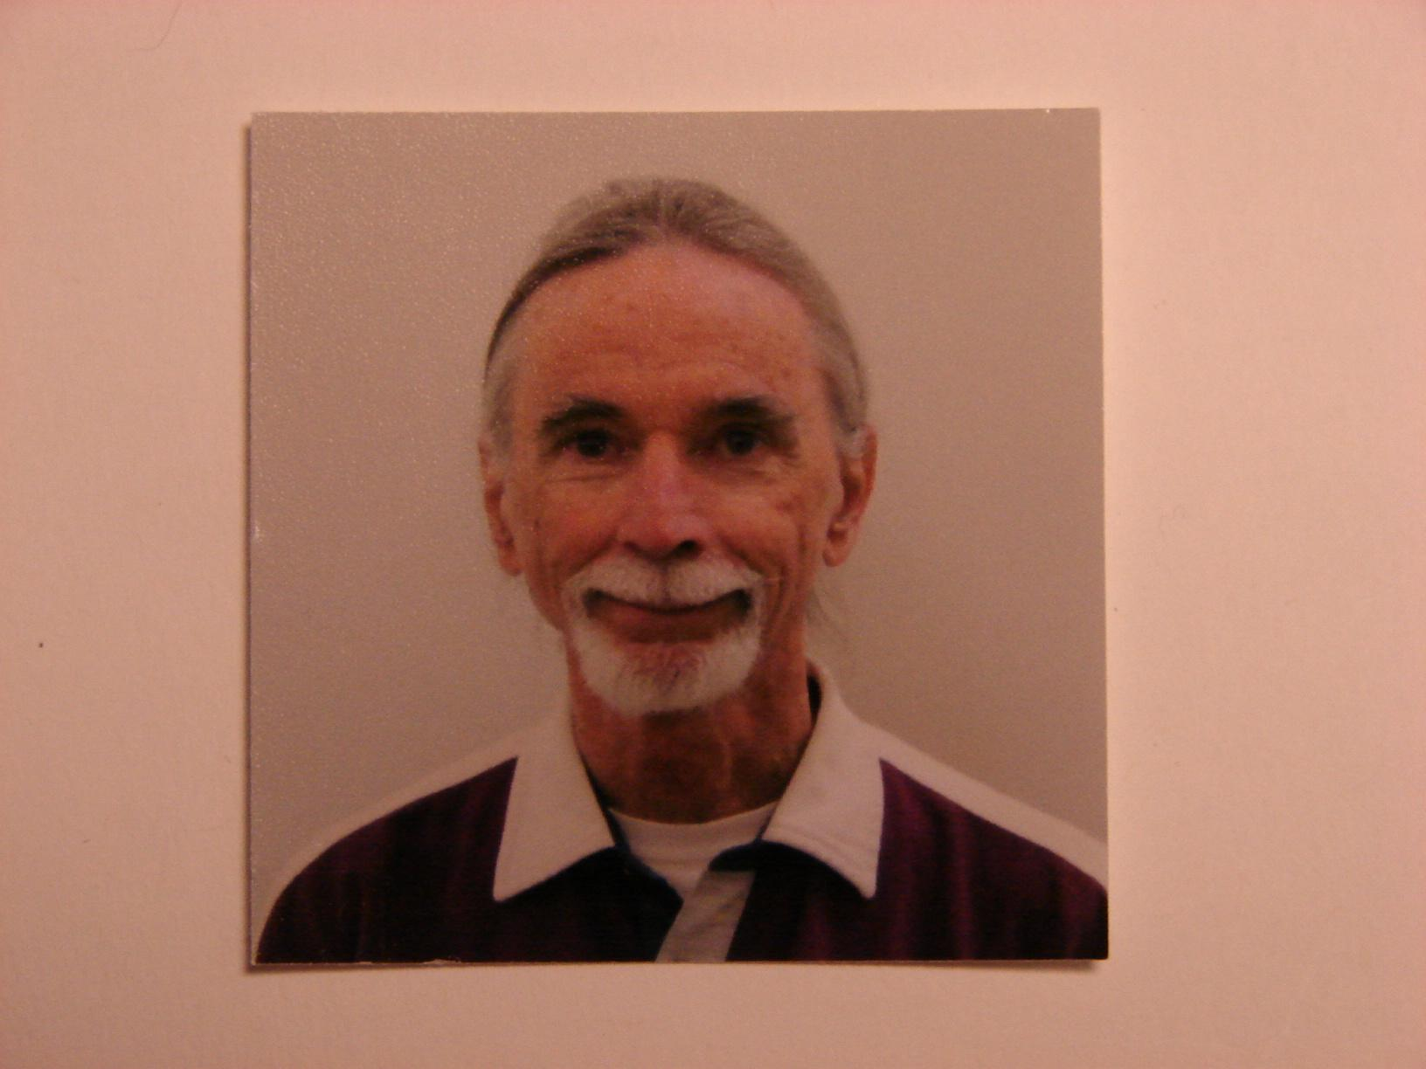

**Inga Popovaite, Crew Scientist / GreenHab Officer**

Inga Popovaite is a PhD candidate at the department of Sociology and Criminology at the University of Iowa. She has MA degrees in Sociology (University of Iowa) and Nationalism Studies (Central European University) and BA in Journalism (Klaipeda University). Her dissertation investigates gender, emotions, and status in space analog environments. Inga will use her time at MDRS to collect primary data for this study.

Originally from Lithuania, Inga plans to move back to the EU after getting her PhD and to continue sociological research on group processes in space analog environments. Inga is interested in how society-wide inequalities and cultural stereotypes shape small crew interactions in isolated, confined, and extreme environments. She has published articles that discuss gender, isolation, and space in [The Conversation US](https://theconversation.com/coronavirus-quarantine-could-provide-lessons-for-future-space-travel-on-how-regular-people-weather-isolation-134762) and [SpaceNews](https://spacenews.com/what-the-2010s-taught-us-about-women-in-space/). She is the lead author of a forthcoming paper in the Journal of Human Performance in Extreme Environments that explores gender gap in simulated EVA participation in analog missions. You can read more about her research on her website [popovaite.com](https://popovaite.com/).

In her free time, Inga swims, bikes, reads science fiction, knits, and makes things with her RaspberryPi.

<photo here. I will send it as a separate file when needed for better quality>

**Jin Sia, Health and Safety Officer**

<Let me know when the website is to be updated and I’ll email the original photo>

Jin Sia is a Master’s research student at Western University in the Department of Electrical and Computer Engineering, with an interdisciplinary specialization in Planetary Sciences. Under the supervision of Dr. Jayshri Sabarinathan, he is helping to develop multispectral imagers for the exploration of the Moon and beyond. He graduated from his Bachelor of Applied Science in mechanical engineering at the University of Waterloo, where his final project was developing a nanothermite space welding system.

Jin was born in Malaysia and moved to Canada at the age of 15 to pursue an education closer to the cutting edge of space exploration. He dreams of one day setting foot on Mars, and hopes to use MDRS as a stepping stone to that goal. Jin believes that the human exploration of Mars is a key milestone in not only opening up a better future for humanity in space, but also to inspire everyday people to live with a cosmic sense of purpose.

At MDRS, he will be conducting research on using GIS (Geographic Information Systems) to facilitate EVA planning and to allow crews to build on the knowledge of the crews who came before. Furthermore, he will be representing the Mars Society of Canada as a member of its board of directors, where he serves as its Vice-Chair and Chief Diversity Officer. Through them, he will blog about his experiences with the aim of making space analog research more accessible and familiar to the public.

Jin enjoys powerlifting, piano, and reading on a variety of topics. His favorite works of science fiction include Dune, the Red Mars trilogy, and the Xeelee Sequence.

------

Stuart Hughes, Crew Journalist (Remote)

Stuart is one of the BBC’s most experienced and respected foreign news producers.

For more than two decades he has covered major news events in more than 60 countries, working alongside many of the best-known names in broadcast journalism.

His assignments have included the 9/11 attacks on the US, the wars in Afghanistan and Iraq, the Arab Uprisings, the death of Nelson Mandela, the Syrian civil war, the migrant crisis and, most recently, the COVID-19 pandemic.

While reporting from Iraq in 2003, Stuart was critically injured when he stepped on an anti-personnel landmine, which led to the amputation of his lower leg. The cameraman he was working with, Kaveh Golestan, was killed in the incident. After learning to walk again, Stuart resumed his career using a state-of-the-art prosthesis.

This life-changing event has given Stuart a particular interest in reporting on the long-term cost of war on civilians and combatants.

Stuart Hughes is a Visiting Fellow at Bournemouth University’s Faculty of Media and Communication. He is also an Ochberg Fellow at Columbia University Graduate School of Journalism in New York and a Kiplinger Fellow in Public Affairs Journalism in Columbus, Ohio.



**Marufa Bhuiyan, Crew Astronomer (Remote)**

Marufa Bhuiyan is the Founder and CEO of Everest Innovation Lab, a space-based organization registered in Hawaii. She is a Systems Engineer, Space Station Ambassador, and a licensed Ham Radio Technician (callsign: WH6GNE). She enjoys playing music, tracking satellites, and is uniquely passionate about astronomy both in real-time and imaginary time.

Ms. Marufa has more than 15 years of experience in stakeholder consultations, literature reviews and technical research activities. She also serves as a Board Members-at-Large for Hawaiian Astronomical Society (HAS), Judge for Hawaii Academy of Science and Judge/GISN member for NASA GLOBE Program etc. Previously, she held various positions at the University of Hawaii at Manoa, Tribhuvan University in Nepal, World Health Organization (WHO) in Bangladesh etc. She holds MS and BS in Biochemistry and Molecular Biology, studied another MS in Electrical Engineering at the University of Hawaii at Manoa. Currently, Marufa is working on several projects e.g., Mars City State design for 1,000,000 population, Interplanetary communication on a mission to Moon and Mars, Digital STEM Engagement in Hawaii and ISS (D-STEMEHISS), writing decadal survey papers for American Society for Gravitational and Space Research (ASGSR) etc. She has some experience in Analog Astronaut Training e.g., Mars Medic Mission 2020 at MDRS (Crew# 220), VALORIA II Mission (2021) at HI-SEAS facility in Hawaii. Marufa has received numerous awards and fellowships e.g., Asia Pacific Leadership Program (APLP) Fellow (2013), GLOBE Judge awards (2020, 2019, 2018), Gold medal from SBA, SENCER Hawaii Fellow (2017) by National Science Foundation and University of Hawaii.

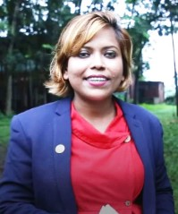

**Yuzo Shibata, Agricultural advisor (Remote)**

Yuzo Shibata is an independent advisor (planning and fundraising) in the field of Science including some Agricultural projects. As an Agricultural advisor (Remote) during this mission, he advises the GreenHab Officer on gathering information from botanists, farmers and nutritionists.

Yuzo is engaged in the field of not only Science but also Art. Through the experience of meeting lots of artists, he has been interested in how "Special Environment" affects “Creativity” (and "Stress") for a long time. For this reason, he has especially supported these kinds of projects, collaborating with neuroscientists, physiologists, physicists and artists. Also he does fieldwork on special environments such as temples, monasteries, ethnic minority villages, army camps and simulated space stations to get a clue about this topic.

Yuzo holds a bachelor’s degree in Agriculture and a master’s degree in Informatics from Kyoto University in Japan. He was one of the benefactors of “Cybathlon” in Switzerland, which is the first international competition for people with disabilities supported by modern assistive technology.

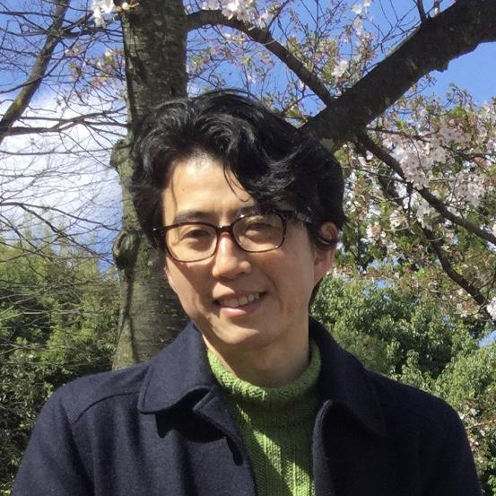

**Charikleia Olympiou, Flight Surgeon (Remote)**

Charikleia is a EU Board Certified Cardiologist with a Master’s Degree in Healthcare Management and a passion for space exploration. Her long term objective is to develop and demonstrate advanced knowledge, understanding and skills in the subjects of space physiology, the understanding of the physiological effects of the space environment upon humans and of the methods employed to mitigate such effects. To engage in research to assess the effects of long-duration spaceflight on the cardiovascular system. To verify strategies for the development of an integrated suite of physical, pharmacologic, and nutritional countermeasures to protect the health and performance of space-faring humans and prevent the practical implications of disease and physical deconditioning associated with long duration space travel.

She has served as the National Point of Contact for the Space Generation Advisory Council (SGAC) in support of the United Nations Program on Space Applications.

Additionally, Charikleia is a volunteer doctor who has been deployed in a humanitarian mission to provide critically needed medical aid to Rohingya refugees in Cox’s Bazar, Bangladesh.

Her hobbies include travelling, collecting vinyl records, photography, reading any book that crosses her path and DIY home projects.



**Ludovica Valentini, Crew Engineer (Remote)**

Ludovica Valentini (class 1995, Italian) is an Aerospace Engineer, currently working as Propulsion Engineer at OHB Sweden, in Stockholm. She is working on projects for the European Space Agency as well as for commercial missions, and she has experience testing propulsion systems and leading manufacturing, assembly and integration activities.

She has a BSc degree in Aerospace Engineering (University of Bologna, Italy) and a MSc degree in Aerospace Engineering with specialization in Space (Royal Institute of Technology, Sweden).

Ludovica is very passionate about space, astronautics and racing cars, and during her university studies she has been part of two Formula Student teams (UniBo Motorsport and KTH Formula Student) and a CubeSat project (MIST).

Her biggest dream is to become an astronaut, and participating in spaceflight analog missions is making her dream come true on Earth instead of in space, for now.

She is curious and eager to learn. She likes traveling, hiking, and doing sport, and she has been a gymnast for fourteen years.

