AREONAUTS

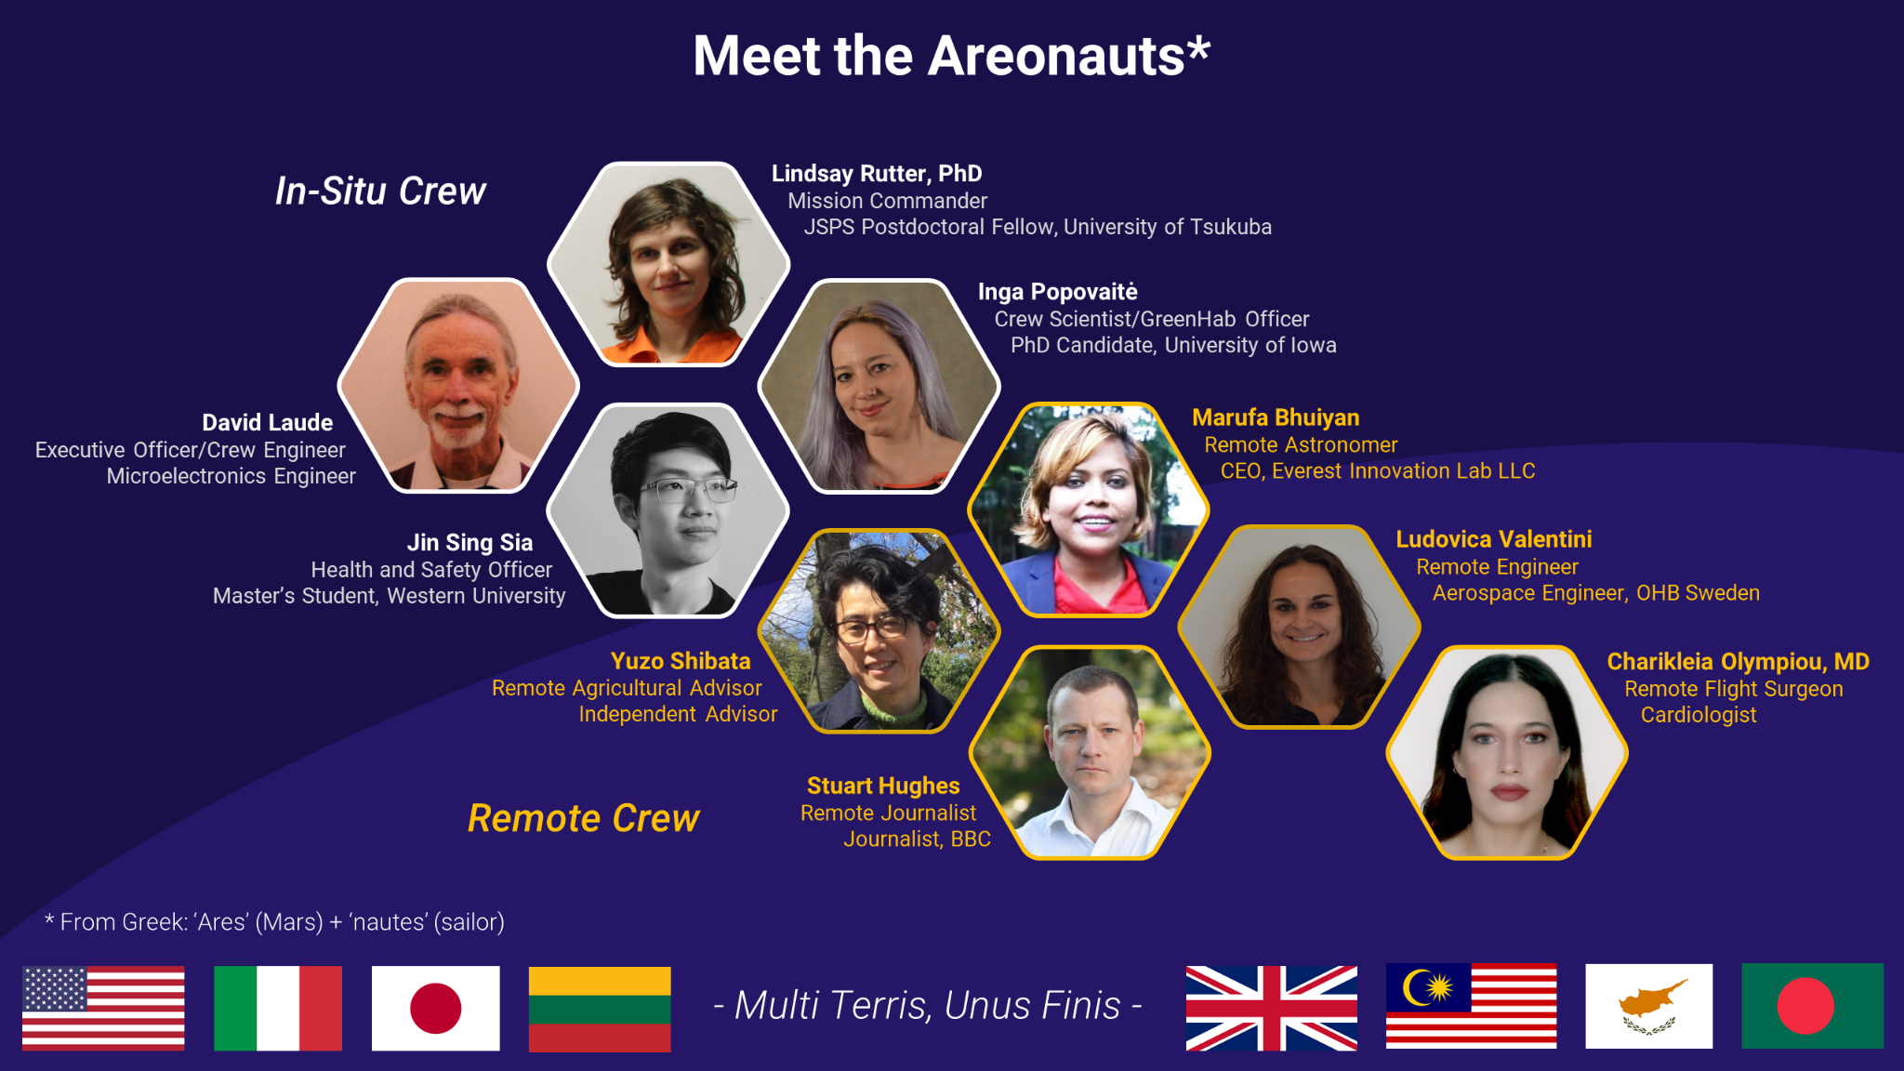

The MDRS 228 crew is an international crew selected by the Mars Society. Our team will travel to the Mars Desert Research Station this year to help put humans on Mars. We are engineers, artists, sociologists, astronomers, biologists, journalists, and physicians, who hail from all walks of life and eight nations. But most of all, we are explorers.

Although we started as a group of strangers who have never met before in person, we share a common goal to serve as “one small step” toward sending humankind to Mars. Over the 2.5 years, we have been carefully preparing for a productive mission on the red planet from all across the globe.

From September 26 to October 9, 2021, we will reside together as “analog astronauts” at the MDRS. Together, we will conduct activities in simulated space conditions. Many compelling experiments cannot be swiftly performed in space due to limitations in time, money, and equipment. Simulated missions like ours can provide humankind with crucial data about the validity of potential space exploration operations.

We will also be proudly wearing our mission patch, conducting research activities, and performing outreach projects. To see more about the symbology of our mission patch and details about our research and outreach activities, please view our mission website at:

https://mdrs228.github.io
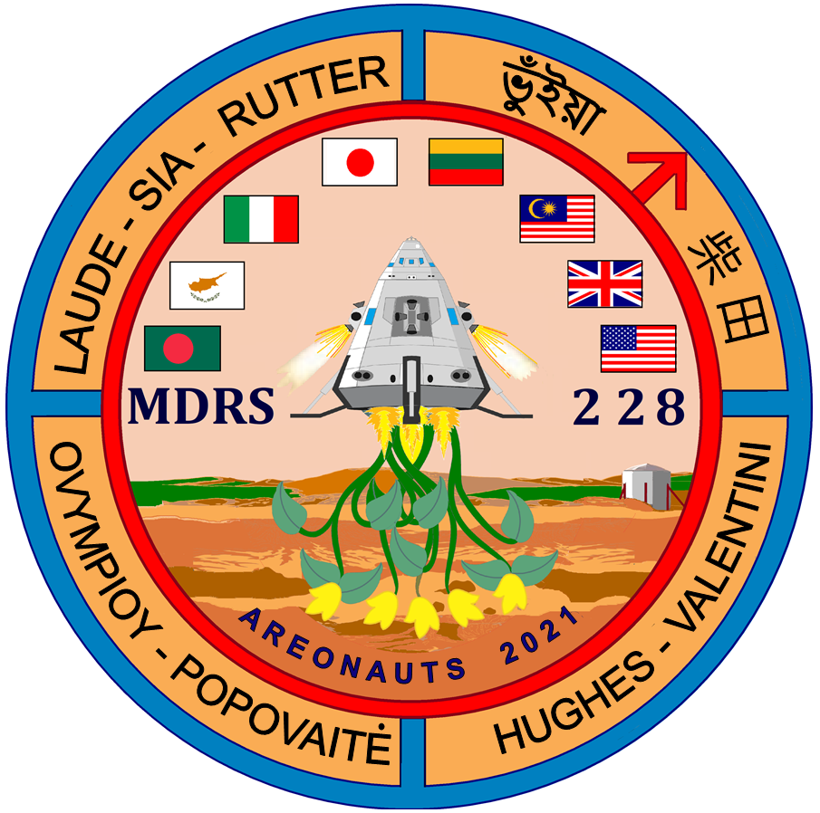

RESEARCH PROJECTS

Gender, emotions, and status in space analog facilities: ethnographic data collection (University of Iowa IRB #201911141)
By: Inga Popovaite

During her time at the MDRS Inga will collect data using participant observation methodology for the last chapter of her dissertation. This project is approved by the University of Iowa IRB (#201911141). This study will examine crew interactions from the structural (as opposed to the individual) perspective, and will contribute to the growing body of literature that examines group processes in isolated, confined, and extreme environments.
.

Gender, emotions, and status in space analog facilities: emotion journal pilot study (University of Iowa IRB #201911141)
By: Inga Popovaite

In addition to participant observation, Inga plans to test data collection instruments for another part of the research project that examines gender, emotions, and status in space analog environments (University of Iowa IRB #201911141). Crew members will be given individual journals and will be asked to write daily entries based on provided prompts. The prompts ask participants to reflect on their emotions, experiences, and interaction with other crews during the day. Unlike the actual future study, this time crew members will be asked to provide feedback on their experience while journaling, such as time commitment, challenges, etc. The goal of this task is to improve journals as data collection instruments before using them in the future.

MDRS GIS map update
By: Jin Sia
In collaboration with: Marc Levesque

The current GIS map of MDRS is in need of updates. Marc Levesque has requested that the necessary changes be communicated back to him by sending him physical copies of the map that have been marked up. Dr. Shannon Rupert has marked up one map of the area with corrections.
Additionally, Marc will provide the crew with new four copies of the map. He has requested that one of them also be marked up with the crew’s and Shannon’s edits.
Both edited maps will then be collected by Jin and mailed to Marc. Marc will then transfer these edits into the MDRS GIS map, which is in digital form.
Jin will also collect answers to the following questions and deliver them to Marc to determine next steps:
- What MDRS geographic data is currently archived in the NAD27 datum?
- What is the reason that the current MDRS standard geographic projection is NAD27?
- If the geographic data have been stored digitally in NAD27, could they be migrated to WGS84 as the new standard?

GIS mapping of MDRS area
By: Jin Sia
In collaboration with: Marc Levesque

Jin will experiment with setting up a GIS map that is a ‘living document’ meant to be updated by crew after crew, permitting the accumulation of scientific data beyond the two-week length of a rotation. The map is designed with the primary objective of facilitating EVA planning by presenting data in an easy-to-use digital format, with both scientific and safety information readily available. During the rotation, Jin will refine the workflow for entering and retrieving data.
The project aims to answer the following research questions:
- How can GIS minimize the time, effort, and required expertise for the planning of an EVA?
- How can GIS maximize scientific return and safety for the execution of an EVA?
- What workflow is best for adding and updating geographic data in a digital map?
- What insights can be extracted from the accumulation of geographic data?
The detailed project plan is available on request.

Future MDRS Research Project Conceptual/Exploratory Investigation
By: David Laude

Dave has been thinking of investigating the prospects of a research project for my next rotation should I be so fortunate. Dave doesn't know if this particular project has been done before and I think it’s a good use of some time at MDRS. Dave would need most or all crew member’s voluntary participation. It’s very simple and can provide very important insights. What would a nascent Martian colony want to be different on Mars from the culture and civilizations on Earth for the better? Why not ask those in a Martian sim? Dave expects that two 1 hour sessions might be enough time.This type of research is outside his area of expertise and so he has reluctance to try a full research project during Crew 228.

In-situ, real-time metagenomics analysis of MDRS regolith using the Oxford MinION
By: Lindsay Rutter

In this project, Lindsay will add to a unique body of astrobiological research that has been conducted by scientists at MDRS. She will add the next logical “stepping stone” in this stream of work that started 16 years ago. Below is a timeline of the previous work and how her project will build to it.

2005: Moran et al. confirmed the presence of methane in the Utah desert soil around MDRS (Moran et al. 2005). The authors provided preliminary evidence (using growth medium) that the methane could be derived by microbes, a finding that, if verified, would be intriguing given that methanogens were not known to survive in desert regolith.

2011: Direito et al. (Direito et al. 2011) and Thiel et al. (Thiel et al. 2011) conducted 16S rRNA studies and PCR-based detection surveys at MDRS. Both groups confirmed high bacterial diversity in the Utah desert soil.

2020: Maggiori et al. (Maggiori et al. 2020) performed the first metagenomics study of Utah desert soil around MDRS using the nanopore sequencing technology of the Oxford Nanopore MinION (Jain et al. 2016). Metagenomics (the study of genetic material collected directly from environmental samples) is a new approach that allows biologists to examine all members in a microbial community at once (regardless of whether they can be cultured). They characterized a rich microbial community that included several methanogens, which verified the unexpected preliminary evidence from 2005 that methanogens can indeed survive in desert conditions.

This proposal would represent the first to investigate not just the microbial diversity (metagenomics), but also the microbial ecology (metatranscriptomics), of the Utah desert soil around MDRS. This would allow us to increase the resolution and understand not just what microorganisms are present, but also what biochemical pathways and substrates they use to survive. Overall, the project will use MinION to sequence DNA and RNA to identify methane-producing metabolic pathways of the methanogens that were recently
detected for the first time in the desert environment.

Maggiori et al. (Maggiori et al. 2020) performed their MinION sequencing on MDRS samples returned to their home lab. In contrast, Lindsay will perform “handheld” MinION sequencing in-situ at the MDRS as a proof-of-concept that sequencing can be done in remote space analog environments far away from sequencing facilities, all while under planetary exploration operations.

Mars City State Design for 1,000,000 Population: An Integrated Model-based Approach towards Martian Settlements
By: Marufa Bhuiyan

Mission plan: Marufa will be based in Hawaii during the mission and she plans to do virtual meetings with the crew to discuss Mars city state design for 1,000,000 population. In real-time it may take 100 years but we are talking about “imaginary time” here (at a 45 degree angle). Every crew can choose their locations, strategy and projects to contribute their ideas for a self-sustaining city on Mars. We are pleased to inform that Marufa’s abstract got selected last year, and this year’s conference i.e. 24th Annual International Mars Society Convention will be held on Oct 14-17, 2021. You can register here: https://www.marssociety.org/conventions/2021/. She will be speaking in a panel for 25 mins and 5 min Q & A. Before she speaks in the conference, she will be happy to share her internal databases, presentation and tools with the crew for Mars city state design for 1 million population. It should be fun, we can take each-others feedback for a case scenario e.g. let’s imagine if you were given the planet Mars, how would you like to rule! :)

OUTREACH PROJECTS

Areonauts sharing their mission with elementary, middle, and high school students
By: Lindsay Rutter, Stuart Hughes, Yuzo Shibata, Olympiou Charikleia, Marufa Bhuiyan, Ludo Valentini, Inga Popovaite, Jin Sing Sia, and David Laude

This project is led by Stuart Hughes and Lindsay Rutter, with participation from all other crew members (Yuzo Shibata, Olympiou Charikleia, Marufa Bhuiyan, Ludo Valentini, Inga Popovaite, Jin Sing Sia, and David Laude). Lindsay Rutter gave virtual presentations about our mission to elementary students (4th and 5th grade), middle school students (7th grade), and high school students (11th grade) through the program “Skype a Scientist”. All together, the presentation about our mission was seen by about 250 students, many of whom sent in questions afterward.

Ludovica will also present the crew 228 and their mission to some high school classes in her hometown in Italy. The students will be encouraged to raise any questions and/or curiosity they might have about spaceflight analogs, Mars and the topic in general.

During the mission, our crew will answer all student questions at least in written format. The questions from the students spanned various fields from space farming to life support system engineering to planetary science to space medicine. With diverse expertise, our crew will work together to answer the questions as best as possible.

After we answer all questions in written format, we will select about 20 questions and answer them in video format. The in-situ crew will show off the habitat while answering questions and the remote crew will show how they support the mission remotely. Stuart Hughes will then collect the footage of our answers and edit it into an engaging and dynamic video. We will then send the video to all classrooms that participated. We will also send mission patches to several of the classrooms.

Areonauts at the Space Week 2021
By: Ludovica Valentini
Supported by the whole crew

Ludovica will present the crew 228 and their “hybrid” simulation, at the MDRS and from remote, during the Space Week 2021 organized by a municipality in the Italian region Marche. This will be achieved thanks to the in-situ crew collecting material such as videos and photos, and thanks to the contribution of the remote crew supporting with editing the footage from “Mars” and providing inputs and feedback about their remote simulation.

Media outreach
By: Inga Popovaite

Inga will be filming videos and taking pictures for Lithuanian media and for the University of Iowa alumni magazine.

Blogging from Mars
By: Jin Sia
On behalf of: Mars Society of Canada

Jin will be writing daily diary entries to be posted to the Mars Society of Canada’s website. These will be targeted at informing the general public about what life is like in a Mars analog.

Future Cafe on Mars: Year 2049
By: Marufa Bhuiyan

Following the instructions below we can envision how the future cities on Mars will look like in our Future Cafe 2049:
- Brainstorm ideas/drivers
  - Pick 2 drivers
  - Label poles: yes/no , high/low, more/less etc.
- Describe each quadrant:
  - Give each a name
  - Think about all the sectors
- Imagine waking up in that future. How would it feel or look?
- Consider your case
- Name one action you would need to do in each future for your cause to be successful.

RECREATIONAL PROJECTS

Movie nights
By: All crew

- Galaxy Quest
- Spaceballs
- Moonbase 8
- Away

Discussion nights
By: David Laude

David is initiating evening discussions about anything interesting that each crew member in turn can suggest.

Radio Reception Experiments
By: David Laude

David Laude has a 1924 radio with him. The crew is planning to set it up to see what signals can be caught from Earth.

Star Party: Find your constellations and name them if you can!
By: Marufa Bhuiyan

Marufa plans to lead a start party helping other crew members identify stars and constellations. She will introduce history, science and mythology connected to the visible night sky.

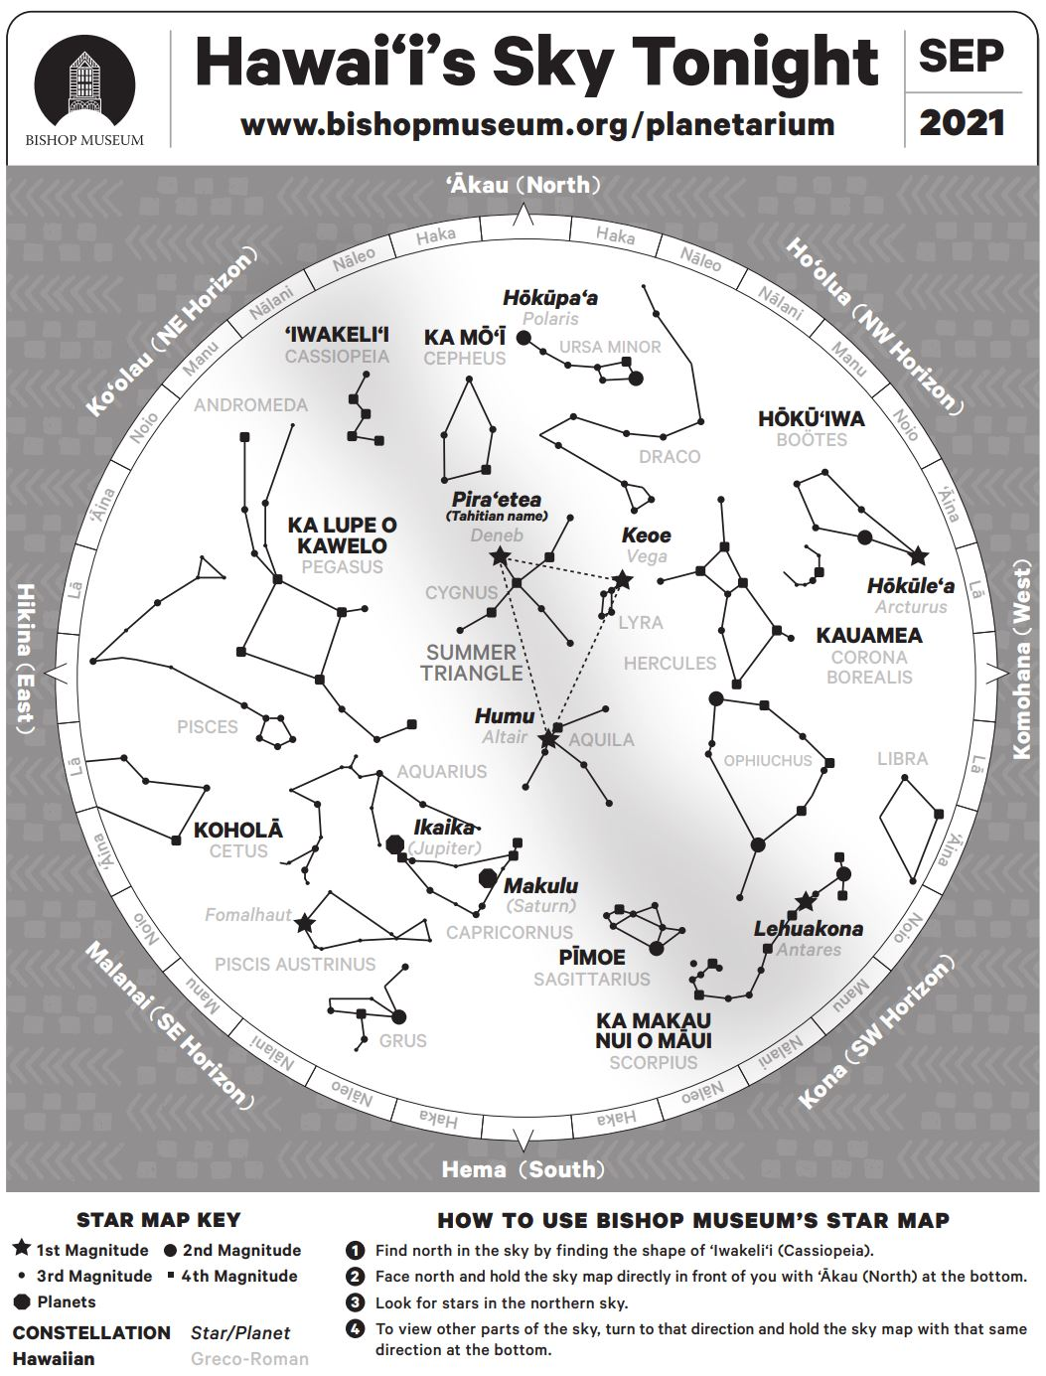

The Bradbury Landing Novel Ideas Club
By: Lindsay Rutter

Our crew can hold a book club to discuss our favorite books related to space exploration. For starters, we can discuss two books, Gila Lost and Found: Search and Rescue in New Mexico (by Marc Levesque) and Strangest of All: Anthology of astrobiological science fiction (by Julie Nováková).

Lindsay has virtually corresponded with Marc Levesque for about two years. Marc was crew commander of MDRS Crew 216 and will command another MDRS mission in April 2022. He is Incident Commander with the New Mexico State Police Search and Rescue, where he manages rescue missions for lost, injured, and stranded individuals. He worked for the US Antarctic Research Program in the 1980s, where he provided science support in one winter-over and two austral summer missions. Marc recently published this book and kindly sent a copy to Lindsay at the Rock Shop of the Hanksville Spaceport. Lindsay will bring the book to MDRS to share with the crew. We can discuss how some of the search and rescue schemes can be applied to Mars EVAs.

Lindsay met Julie Nováková at an AbGradCon conference, where Julie provided access to her book about the search for extraterrestrial life. The book is an anthropological format with short science fiction stories (mostly written by scientists) about possible scenarios of discovering life outside of Earth. Ethical scenarios are also raised. We can discuss these stories and engage in constructive debates about the ethics related to this field of life detection exploration.

REFERENCES
Direito, Susana O. L., Pascale Ehrenfreund, Andries Marees, Martijn Staats, Bernard Foing, and Wilfred F. M. Röling. 2011. “A Wide Variety of Putative Extremophiles and Large Beta-Diversity at the Mars Desert Research Station (Utah).” International Journal of Astrobiology. https://doi.org/10.1017/s1473550411000012.
Jain, Miten, Hugh E. Olsen, Benedict Paten, and Mark Akeson. 2016. “The Oxford Nanopore MinION: Delivery of Nanopore Sequencing to the Genomics Community.” Genome Biology. https://doi.org/10.1186/s13059-016-1103-0.
Maggiori, Catherine, Jessica Stromberg, Yolanda Blanco, Jacqueline Goordial, Edward Cloutis, Miriam García-Villadangos, Victor Parro, and Lyle Whyte. 2020. “The Limits, Capabilities, and Potential for Life Detection with MinION Sequencing in a Paleochannel Mars Analog.” Astrobiology. https://doi.org/10.1089/ast.2018.1964.
Moran, Mark, Joseph D. Miller, Tim Kral, and Dave Scott. 2005. “Desert Methane: Implications for Life Detection on Mars.” Icarus. https://doi.org/10.1016/j.icarus.2005.06.008.
Thiel, Cora S., Pascale Ehrenfreund, Bernard Foing, Vladimir Pletser, and Oliver Ullrich. 2011. “PCR-Based Analysis of Microbial Communities during the EuroGeoMars Campaign at Mars Desert Research Station, Utah.” International Journal of Astrobiology. https://doi.org/10.1017/s1473550411000073.

