Crew 227 Mission Summary Report 07-04-2022
Summary Title: A Tharsis odyssey
Author’s name: Cyril Wain
Mission Status: Crew Commander
Sol Activity Summary:
What an experience!

The Tharsis mission, a simulation of a manned mission on the planet Mars, started on March 27 at the Mars Desert Research Station (MDRS).
This mission was created by M.A.R.S UCLouvain, a non-profit organization made up of 8 Belgian students and researchers from UCLouvain. These 8 members are:
Crew Commander : Cyril Wain, civil electrical engineer
Executive Officer : Jean Jacobs, PhD
Crew Scientist : Audrey Comein, PhD
Greenhab Officer : Cheyenne Chamart, master student
Crew Astronomer : Ignacio Sanchez Casla, master student
Crew Engineer : Julien Meert, master student
Crew Health and Safety Officer : Julie Manon, PhD
Crew Journalist : Sirga Drouet, Bachelor student
The goal of this mission was to realize a 2-week simulation in an isolated station located in a Martian environment. The objective was at the same time scientific, human and social. During this report, I will describe our 2 weeks mission based on these 3 aspects.

Scientific:

The Tharsis mission was extremely rich in terms of scientific experience. Indeed, each member of the team, in addition to his role within the station, had a very specific experiment to realize. Below, a short description of the different experiments performed and some of their results.
Cyril: The goal of the experiment was to perform field measurements using a Ground Penetration Radar (GPR). From these measurements, it is possible to deduce the dielectric properties of the soil and thus deduce the presence of water or not in the soil. To complete these data, a 3D modeling of the studied areas were realized via drone. The 3D modeling went well. However, the radar had some small problems that could not be solved until the end of the simulation. The data are still being processed.
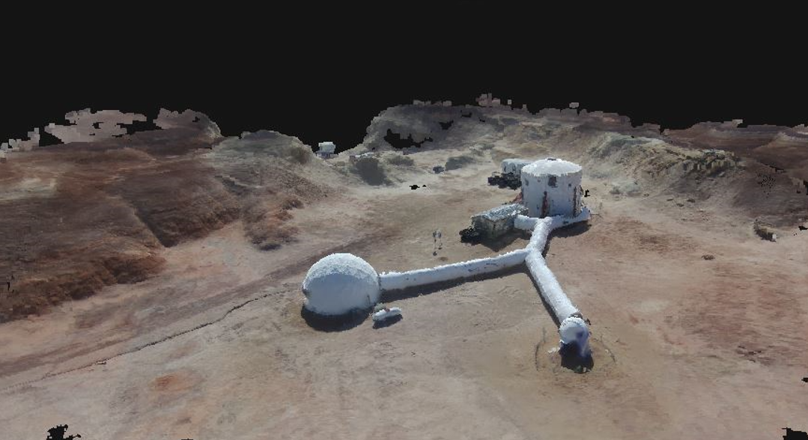
Jean: Development of a protocol for daily monitoring of health and physical activity of astronauts by analysis of body fluids via mass spectrometry and ECG. Most of his measurements are still under analysis. However, from his first observations, it seems that the physical activity spent within the station is very low whereas the physical activity spent during a 3h EVA corresponds to a normal continuous physical activity of 1h.

Audrey: His experiment consisted of exposing bacteria collected from the skin and saliva of astronauts and then exposing these bacteria to the environmental conditions in and around the station. Also, to compare their survival rate compared to a control situation (bacteria remained in the science dome). The first results showed that the exposed bacteria significantly reduced compared to the control bacteria.
Cheyenne: Studied the difference in germination and growth of two edible plant species in three different substrates and three different locations in the MDRS. The results showed that when the plants were placed in the greenhouse, only the species present in the germination medium grew. The best results were observed in the grow tent of the science dome and those positioned in front of the science dome window. In the substrate of martian regolite, no plant exceeded the state of germination.
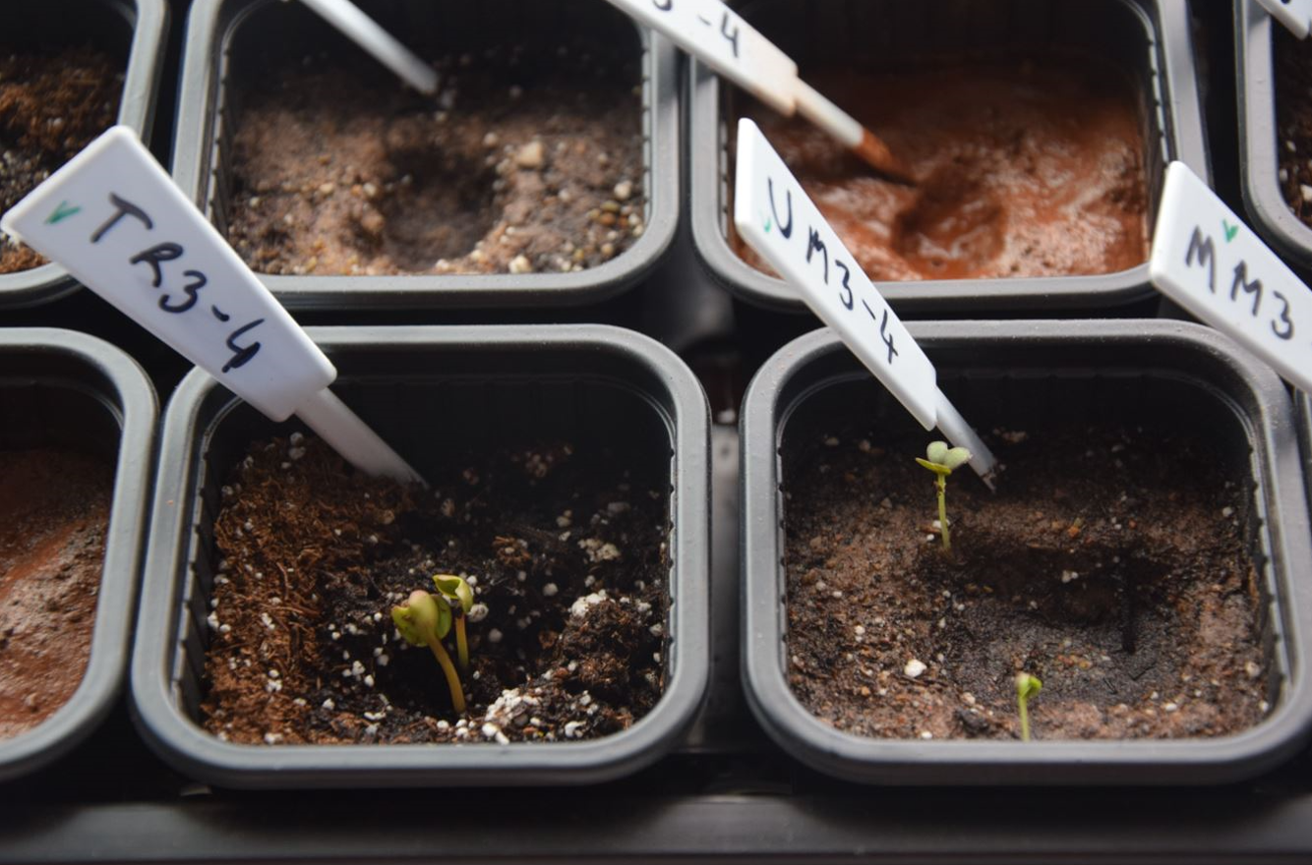

Ignacio: His experience consisted in supporting the rest of the team with his 3D printer. During the 2 weeks he was a great help, even for things that we had not planned at all, typically the knob of the stove. The conclusion is that the 3D printer is an incredible tool for this kind of mission during which many unexpected things can happen.
Julien: His experiment was to study the sleep of astronauts and how it can be improved by hypnosis sessions. The conclusion was that astronauts who responded to hypnosis had a deeper and more restful sleep than others. However, overall, the astronauts had a lighter sleep than normal.
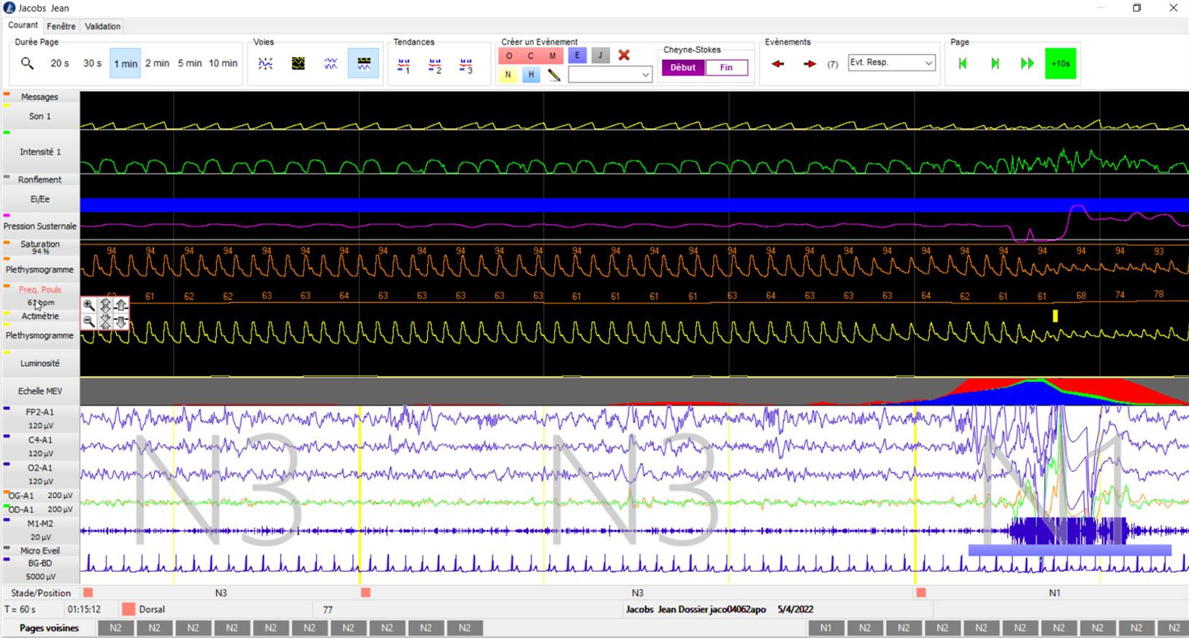
Julie : His experiment consisted in teaching astronauts how to manage a long bone fracture (e.g. tibia) using an external fixator. In order to do this, different sessions of matches were carried out. Firstly, in classic learning conditions and then in so-called stressful conditions + situational simulation (EVA).
The results showed that the confidence and learning curve of the astronauts increased over the 2 weeks while respecting a precise timing and the safety of the patient.
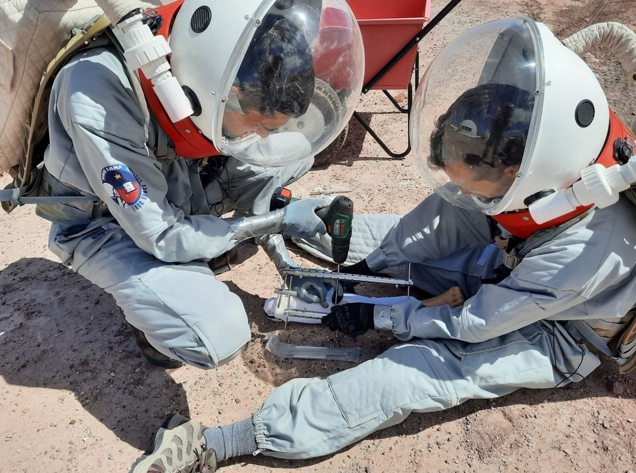
Sirga: His experiment consisted of making meals with insects and studying the reaction of astronauts. The conclusion is that the main factor that bothers astronauts is the visual aspect. The solution is to "hide" the insects by crushing them. Also, it was noticed that when astronauts were not aware of the presence of insects, they did not necessarily notice it.
In addition to these personal experiments, a global experiment was also conducted in collaboration with Nasa and JPL. This experiment consists in using a sheduling with an embedded AI. This tool aims to help us to achieve all our tasks in the given time. The fact is that in the ISS, astronauts follow a well-defined program to the minute. On Mars, due to the longevity of the mission as well as the delays in communications, it is no longer possible to follow such a schedule and that is therefore the goal of this new tool.
Human :

This mission was also human. Indeed, 8 analogous astronauts experienced a two weeks life in isolation. During these 2 weeks, the astronauts did not have access to Internet except during the capcom windows and only for this purpose. From then on, we were totally disconnected from reality.
At the beginning, we regularly wondered about what was happening in the world, especially in view of the current geo-political climate. As the mission progressed, we no longer felt the need for information and focused on what was directly affecting us: our experiences.
Also, we lived in a small environment. We noticed that we still had access to everything we needed and that we often surround ourselves with useless objects.
Following this simulation, we noticed that we sometimes concentrated too much on what was happening far away and which did not concern us directly. From then on, we will pay more attention to everything that surrounds us more directly and on what we can have a real impact.

Social:

Finally, this mission also had a social aspect. Indeed, we were 8 students and researchers from 20 to 30 years old isolated in a small station. We all knew each other from our mission preparation meetings. However, thanks to this break from the outside world, we had the opportunity to discuss a lot of subjects that we would never have taken the time to talk about in normal times. All these debates have taught us a lot and made us grow.

It is certain that we all know each other much better than when we arrived and this group will always have a special place in our hearts, it will always be the one with which we lived a unique experience.

To conclude, we all had an incredible experience and we all came out of it stronger. We are already looking forward to telling our families and friends about all our adventures and to share all that we have discovered and learned.

On behalf of the whole team, we thank you for this incredible adventure that will remain forever engraved in our memories!
