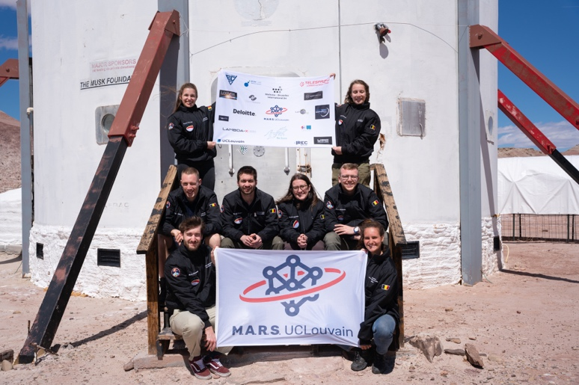
During these two weeks, Crew 279 ARES has continuously worked on their research. Our experiments cover a large range of topics, and we hope to get good results out of our efforts. We still need to analyze all the data post-mission to conclude our research but here is a brief overview of how our experiments went during our rotation.

“We are what we eat” – Antoine de Barquin
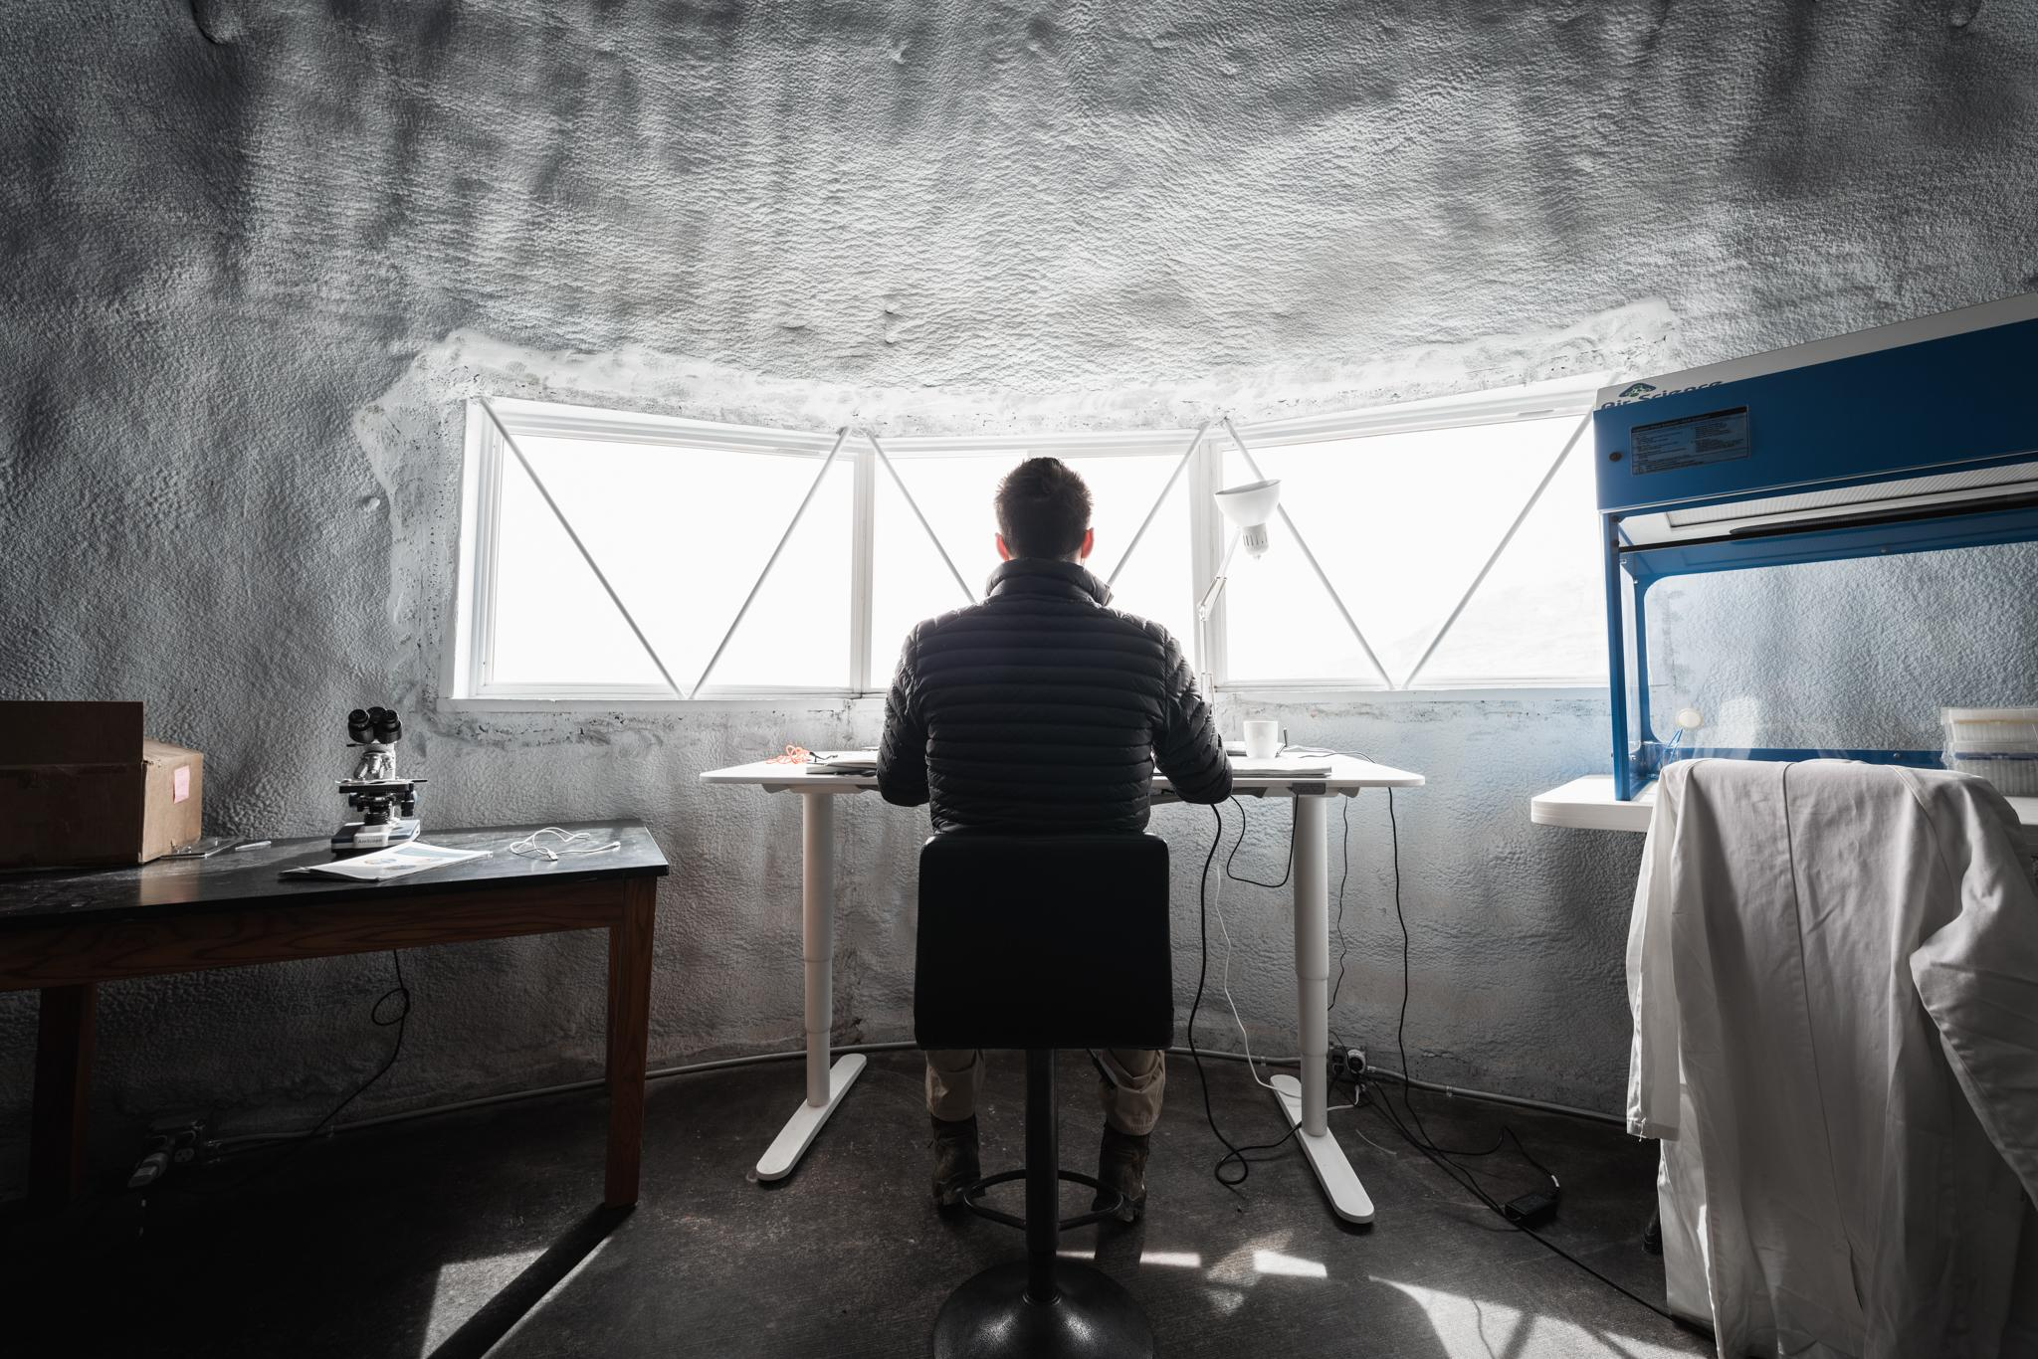
The goal of Antoine’s experiment is to understand the impact of specific nutrition and confinement on the intestinal flora of astronauts. To conduct this study, a sample of each crew member was taken before departure to perform an analysis of intestinal bacteria by targeted metagenomics. This analysis is performed at the LIMS MBnext laboratory which collaborates with our crew for this experiment. The crew will then give “post-mission” samples. This way, Antoine will be able to compare and analyze how freeze-dried food affected everyone’s microbiota. Every day, Antoine monitored everything the crew ate, type of food, quantities, time of the day etc. He started analyzing the data during the mission and will conclude the analysis after the return on Earth. He also wondered how working the soil would affect the two crew members who worked the most in the GreenHab. People who garden have higher levels of Mycobacterium vaccae, a bacteria found in the soil that stimulates production of serotonin and functions as an antidepressant. He thought it would be interesting to see if our two gardeners have higher levels of it when he analyzes their samples upon our return to Earth.
Our Commander led his team proudly, trying to please everyone and keeping a good overview of the broad range of work we had to do.

“I will survive” – Agnes Dekeyser
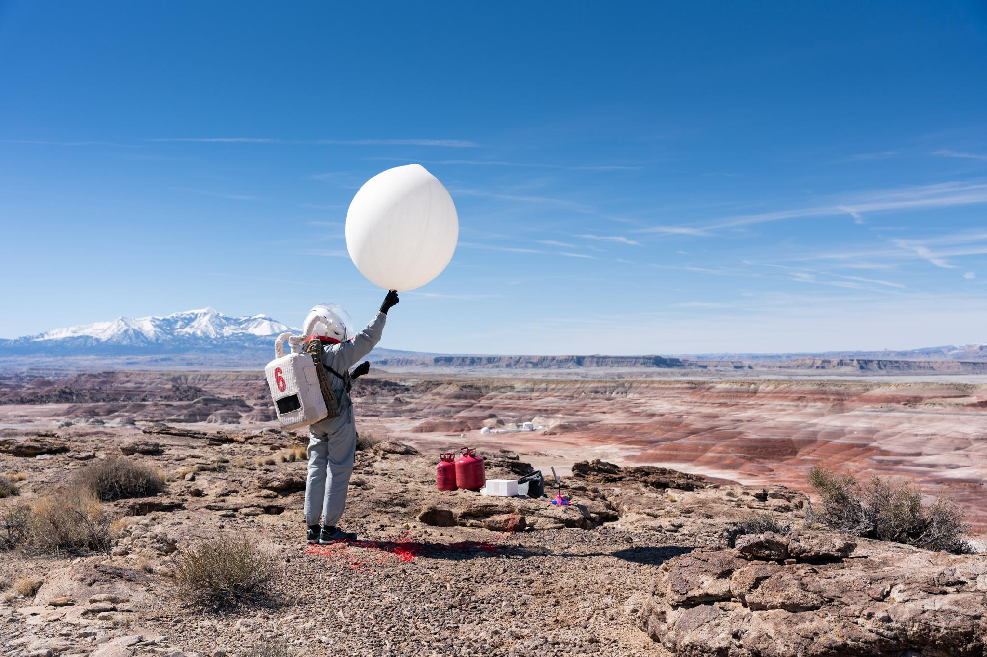
Agnes’ experiment studied “extremophiles”. These are microorganisms that live in conditions that are lethal to most other microorganisms. They live on the seabed, in the Earth’s crust, in glaciers, and in many other extreme environments. During the mission on the planet Mars, our Crew Executive Officer studied the viability of two strains of extremophiles after exposure to MDRS environmental conditions : Deinococcus Radiodurans and Cupriavidus Metallidurans. Each strain was exposed outside for 8 days in anaerobic condition. Their viability will be compared to their unexposed analogues based on CFUs (Colony-Forming-Units) analysis. She also worked closely with Augustin and Thomas to find a place with less radiation around the base where her bacteria could survive better. Agnes spent her first days culturing her extremophiles and used one of her EVA’s to take them to North Ridge, a ridge with a higher altitude than the station’s. She also placed their analog inside the station. She then went back up the ridge every two days to check them. She also used an Arduino to calculate parameters such as temperature, pressure and altitude at North Ridge. On top of this experiment, she launched a weather balloon on top of North Ridge with an Arduino as well to test if this could be a useful way to calculate parameters if bacteria were to be put inside of the balloon for a future experiment. Sadly, the balloon did not last long as it did not have enough helium. SOL 11 was the day she collected her cultures and will proceed to analyze the difference in viability.
As CEO, she helped the Commander organize and coordinate daily team tasks and supported everyone before, during and after the simulation.

“Space Oddity” – Ioana Dimitrova
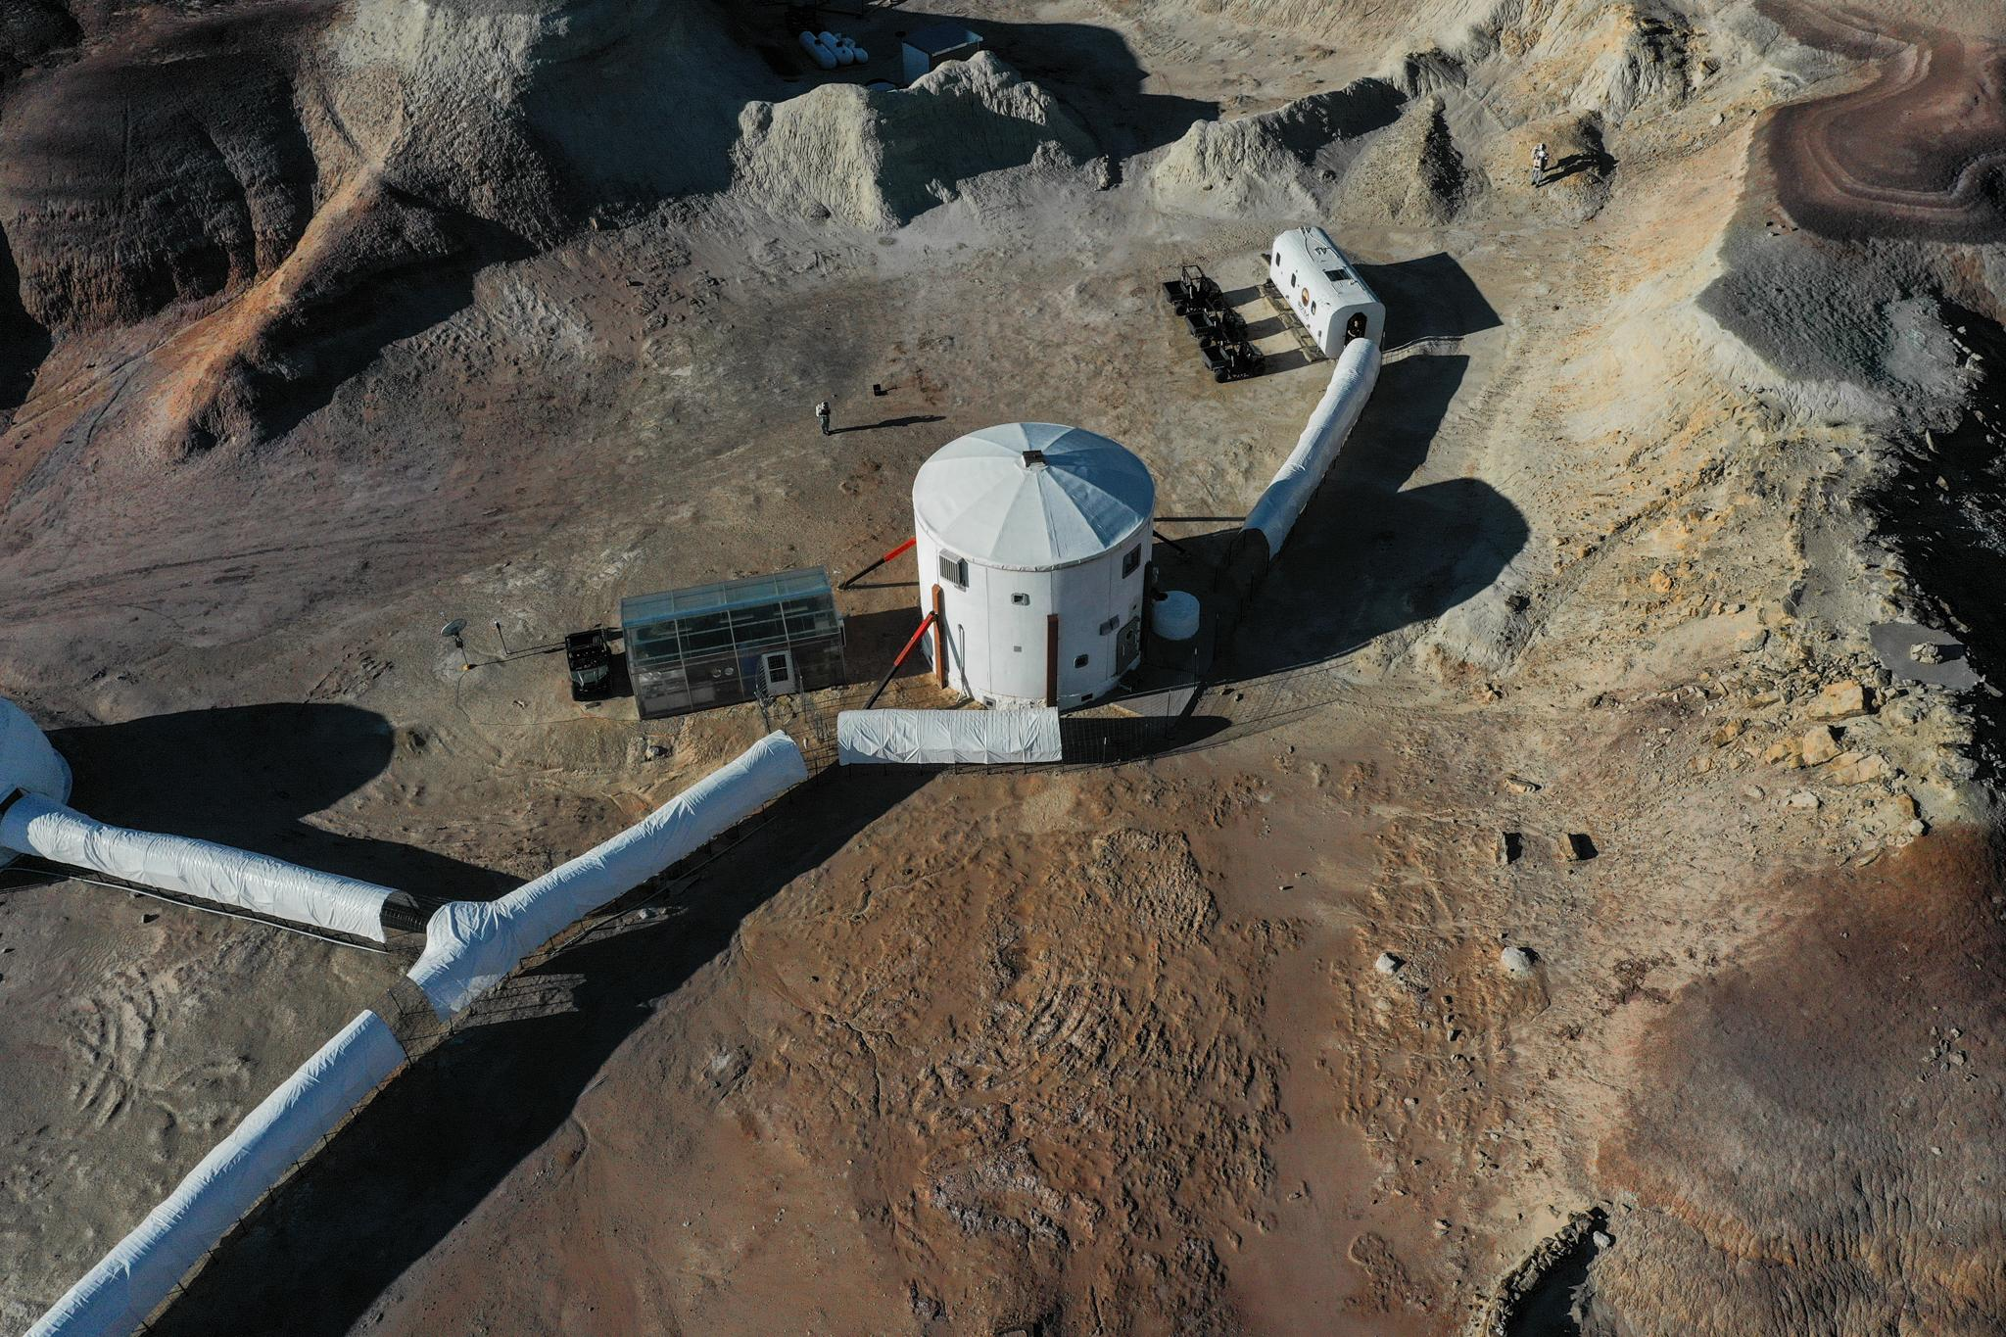
Long term spaceflight separates astronauts from society and their loved ones for months and months. It also keeps them confined without leaving them a possibility to feel free and do whatever they want. This can lead to mental health problems, stress, tensions within the team and can put the mission at risk. Music could be a cheap, easily transportable, and effective solution to this problem. Choosing your personal music to help you relax could have multiple benefits. It could help you transport yourself elsewhere, work through your emotions and stimulate your senses. Ioana tested if this theory is true by measuring cardiac parameters during relaxing times with and without music chosen by the crew. The technology used for the measurements is KINO by HeartKinetics. It’s an app that you put on your chest and that analyzes your heart variability. Added to that, a blood pressure monitor was used to take blood pressure measurements. Before the measurements, she also asked the crew to complete an anonymous Self Perceived Stress Test to get some trends on how the team felt throughout the mission and to correlate it with days they listen to music.
Our Crew Engineer has also kept busy by fixing two suits, a headset and managing water and power consumption.
“Radiation: how attacked are we?” – Thomas Stinglhamber
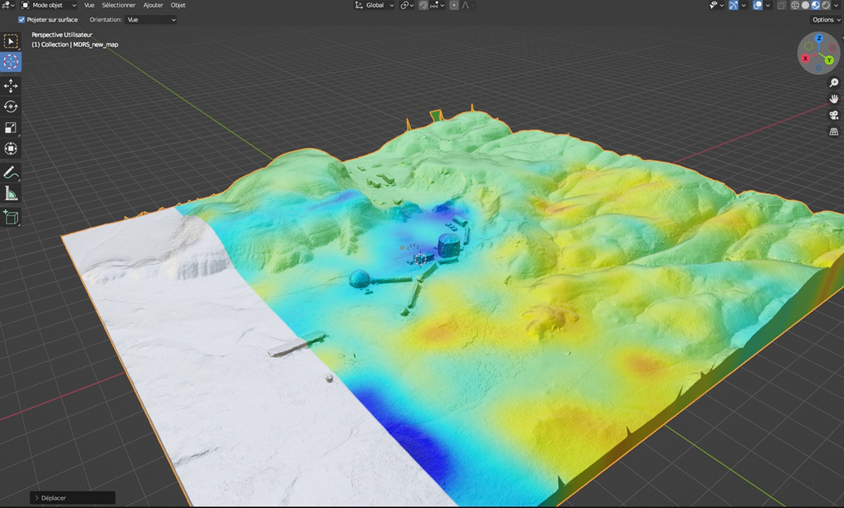
Every day, everywhere, different types of radiation attack us. On Mars, radiation will be way more brutal and dangerous than on Earth due to the difference of the atmosphere. It is thus very important to be able to have easy ways to measure the dosage of this radiation.
Thanks to BeSure’s technology, Thomas installed dosimeters both inside and outside the station to check how radiation proof the station is. He also gave the crewmates an individual dosimeter that they always wore to measure their personal dosage. He will collect all their data at the end of the simulation and will be able to tell us how much radiation we have been exposed to. Complementary to this, Thomas used a Gamma detector to map out the activity of the soil around the station by searching for radioactive isotopes near the station. He covered the whole region around the MDRS and combined his grid with Augustin’s 3D maps. He also helped Agnes determine if the hiding places Augustin found for her bacteria were protected from radioactive activity.
As Crew Scientist, he helps plan EVA’s, their tasks, timings, and reports.

“Confinement FOMO” - Aglaé Sacré
FOMO, “Fear of missing out”, can appear when we are cut out of society and social media. The Mars simulation completely cuts the crew off the network and the outer world, which makes it the best place to study how the lack of social media affects the mental condition of not wanting to miss out on something. The crew answered some anonymous questionnaires before leaving and were asked to check their social media usage data on their phone to realize how much time they were spending online daily. At the half of our stay, different anonymous questionnaires were completed where we assess how we feel without social media and if we feel like we’re missing out on something. We will have one more to fill in after the end of the simulation. This way Aglaé can compare how the crew used to use social media, how they predicted they would live without it and how they lived without it. Early data shows that pre-mission fears evolve as the days go by.
As Crew Journalist, she wrote the daily summaries and kept the world notified on what work we do every day. She also took photos and videos to document and present after our mission

“High Speed Rotor Manufacturing” – Gwenael le Bussy
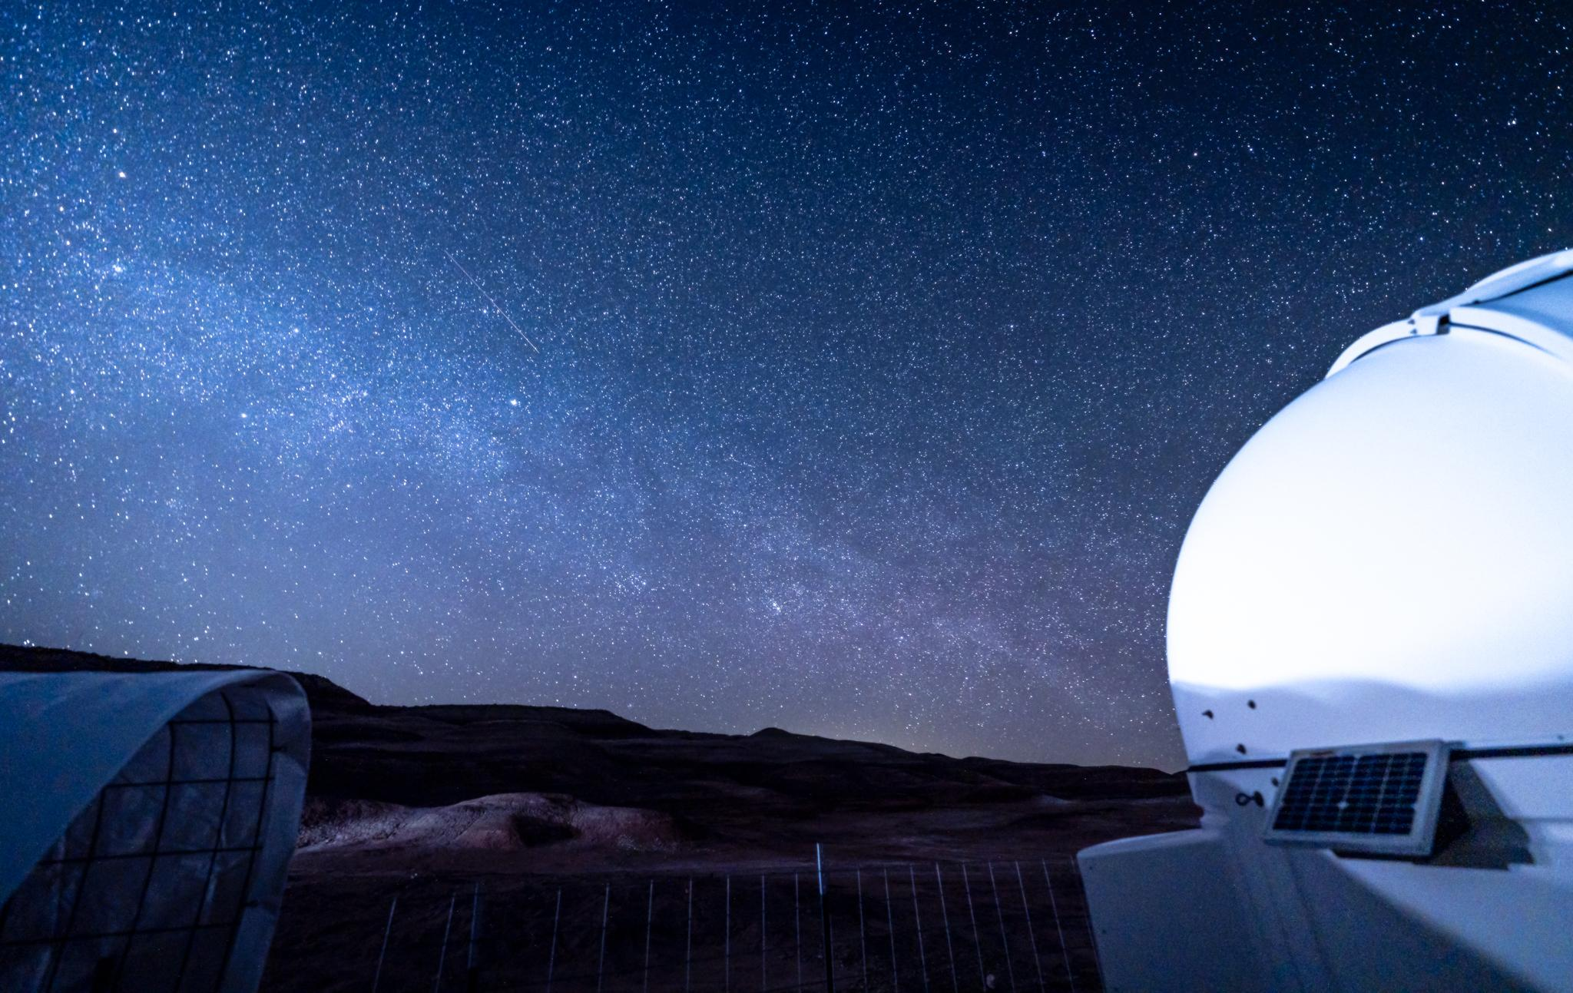
The Martian atmosphere is a hundred times less dense than the one on Earth. This means that every flying object we would like to use for observation, scouting or measurements needs to be adapted to the physics of that new environment. Like the ones on Ingenuity, the rotor blades must have a special shape. Naturally, every piece of equipment may encounter a problem and need to be repaired or replaced. The problem cannot be predicted precisely in advance, which means that we need an adaptable solution. Gwenael studied how he can use 3D printing to model (with SolidWorks with NACA profile) and print rotor blades for the Martian atmosphere. Afterwards, he tested them with a high-speed motor and measured their thrust with a scale. He tested the 3D printer by doing some test prints for the oven knob. We tried to see if we could make one that works better than the ones currently used.
Parallel to his aerodynamics work, our Crew Astronomer observed the Sun with the solar observatory and took some pictures. He also used the New Mexico observatory remotely to observe M63 and M51 and spent some time processing them.

“Hide and seek during radiation storms” – Augustin Tribolet
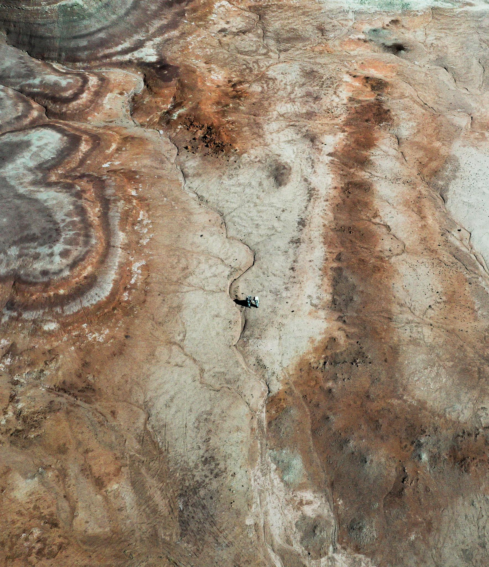
As we mentioned earlier, radiation is an important factor in a Mars mission. If we are to live there or try to make bacteria or plants survive, we must find the most protected areas on the surface. An easy way to be able to find those places could be to use a drone to map out the area and to find these places. Augustin used a drone to scan the surface and generate a 3D model by photogrammetry. This digital technique allows us to build the 3D model from photographic images. He worked closely with Agnes who studied extremophiles to analyze how effective his hiding places are but also with Thomas to map out his radiation with the 3D models. Augustin completed numerous EVA’s during which he mapped out the station, the Special Region, Marble’s Rituals, the North Ridge, Candor Chasma, Kissing Camel Ridge… When he was not on EVA, he exported the images and combined them to create 3D interactive maps. When he would spot a possible protected place on his map, he would send a team out on an EVA, that had never been to that place, to see if they could find it based only on his maps and to check out if his measurements were correct.
As GreenHab Officer, he took care of our garden, rooting for it even during the warmer days. He collected the vegetables and different herbs that he dried to make spices for our team as well as for the next teams.

“Mars well-being” – Ttele Hiriart
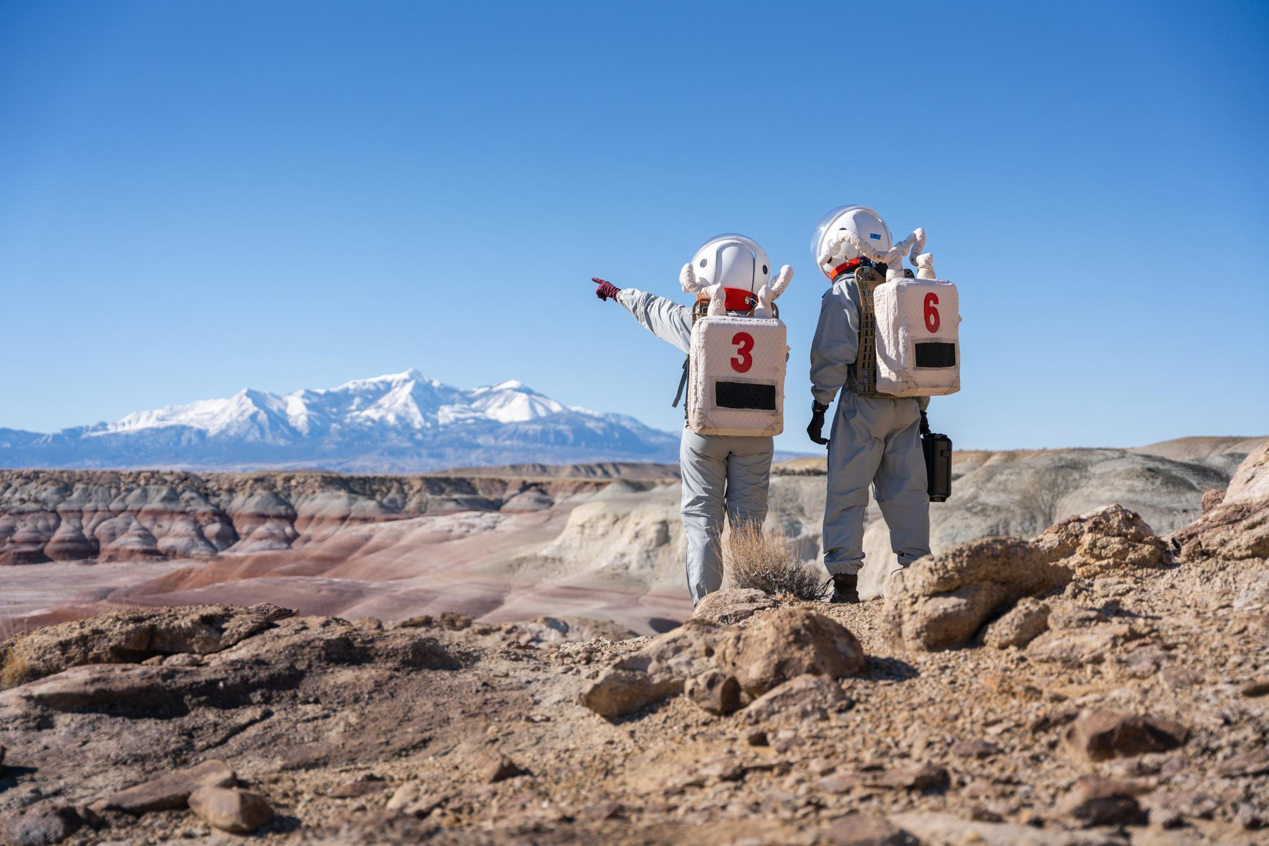
Confinement, isolation, extreme conditions… All these factors affect mental health and team dynamics. How is the well-being of the crew members evolving? How does the team work together? How do the dynamics evolve? Which teamwork tools work? During the mission, Ttele kept a diary of her observations of the team and different crewmates. She will compare these observations with the ones made by other mission simulations in Antarctica for example. After analysis, she will present her observations of the ups and downs of the mission, how the team interacted and different lessons the team has learned or must work on for future missions. During the day, she observed how effectively every crewmember worked on their experiment, how their motivation changed and how they handled difficult decisions, tensions. Some examples included: decisions made during EVA’s when plans had to change due to lack of time, technical difficulties in the station, decision taking when not everyone had the same opinion, how the team reacted when somebody was down, the effect of the fatigue… She also introduced some teamwork exercises at the end of day to work on team cohesion. All this is documented in her diary, and she took notes of her observations continuously. She will now have the tedious task to read everything she wrote and present her observations and some ideas for improvement.
As Health and Safety Officer, she made sure everyone was feeling good and healthy and took care of us when we were feeling out of shape.

