**Mars Desert Research Station**

**Mission Summary**

Crew 305 - Valles

Dec 8th, 2024 – Dec 21st, 2024

**Crew Members:**

Commander and GreenHab Officer: Hunter Vannier

Executive Officer and Crew Geologist: Ian Pamerleau

Crew Engineer: Spruha Vashi

Crew Scientist: Monish Lokhande

Health and Safety Officer: Peter Zoss

Crew Journalist: Rashi Jain

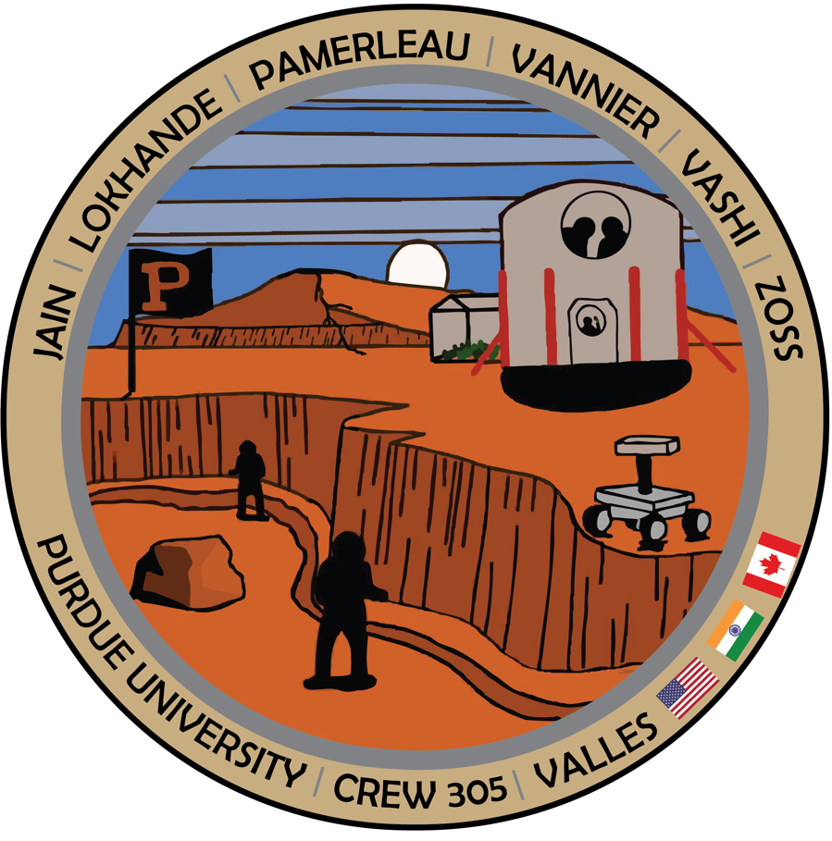

**Acknowledgements:**

The MDRS 305 crew would like to express their gratitude to the many people who made this mission possible: to Dr. Robert Zubrin, President of the Mars Society; Sergii Yakimov, MDRS Director, who assisted us with planning and answered many questions; Ben Stanley, MDRS Analog Research Program Director and David Steinhour, MDRS Site Manager for being invaluable as Mission Support and addressing both large and small problems during our stay; Mike Stolz for patience and consistent communication regarding media relations; Russ Nelson for preparing us for emergencies; Scott Davis for EVA suit support; James Burk, Executive Director; Peter Detterline, Director of Observatories; Bernard Dubb, MDRS IT coordinator; Dr. Kshitij Mall and the Purdue Mission Support staff; the Purdue faculty who greatly helped us in the selection process; all the departments and people at Purdue University who supported this mission; and all the unnamed people who work behind the scene to make this effort possible.

**Mission description and outcome:**

MDRS 305 “Valles”, twin of mission 306 “Montes”, is the eighth all-Purdue crew at MDRS. The diverse crew included two women and four men, represented three countries (United States, India, Canada) and various departments at Purdue, and was comprised of an undergraduate student, PhD students and candidates, showcasing the strength of Purdue student-lead research in the field of space exploration. MDRS’s unique analogue environment and robust campus was both impactful and relevant for Crew 305, as almost every building was in use during the mission. Crew 305 performed a wide range of research tasks, with a strong geological and human-machine compatibility focus that regularly led to collaborative research efforts, a primary Crew 305 theme. The privilege of sending two Purdue crews back-to-back is not lost on us, as multiple experiments will live on during the Crew 306 “Montes” mission to follow.

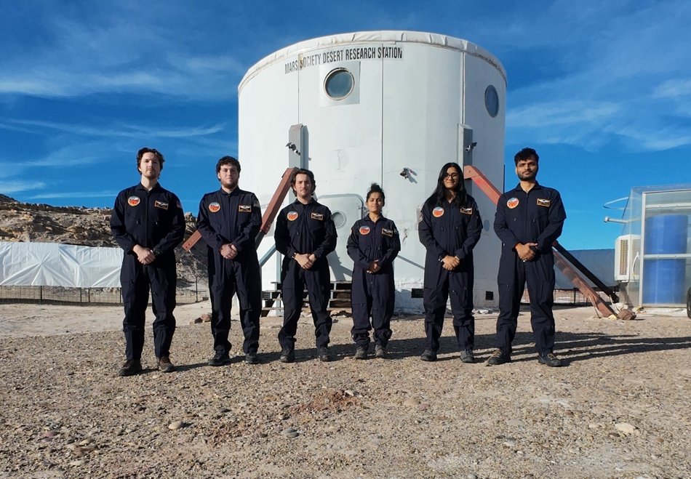

Figure 1. MDRS 305 Crew. Left to right: Executive Office and Crew Geologist Ian Pamerleau, Health and Safety Office Peter Zoss, Commander and Green Hab Officer Hunter Vannier, Crew Journalist Rashi Jain, Crew Engineer Spruha Vashi, and Crew Scientist Monish Lokhande.

**Summary of Extra Vehicular Activities (EVA)**

The crew had twelve EVAs, two of which were the initiation at Marble Ritual, and the remaining EVAs were aimed at gathering data, samples, or observations for one or more crew members’ research (i.e., ephemeral stream measurements and/or paleosol samples. Observations were also taken on how rovers could aid astronauts taking data in the field. EVA teams thoroughly explored the regions in Candor Chasma, Eos Chasma, southeast of Kissing Camel Ridge (KCR) (Fig. 2).

While the EVA team was in the field taking data, the rest of 305 was still involved in the EVA. Every Crew 305 member helped the team gear up, and during the EVA, the comms team back at the Hab would take notes on the EVA team’s movements and details. This information was logged in an EVA spreadsheet that we are leaving as a template for future crews to use.

Table 1. EVA Sol, destination, time spent walking and taking data, total time, walking distance, and total distance.

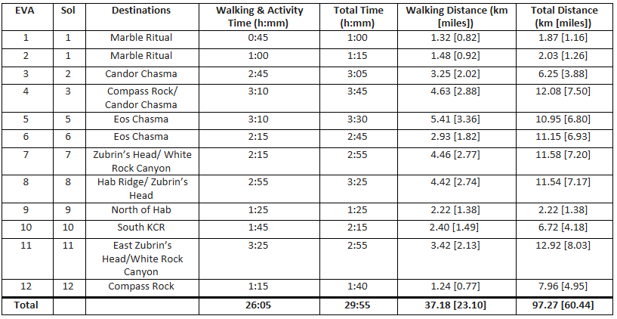

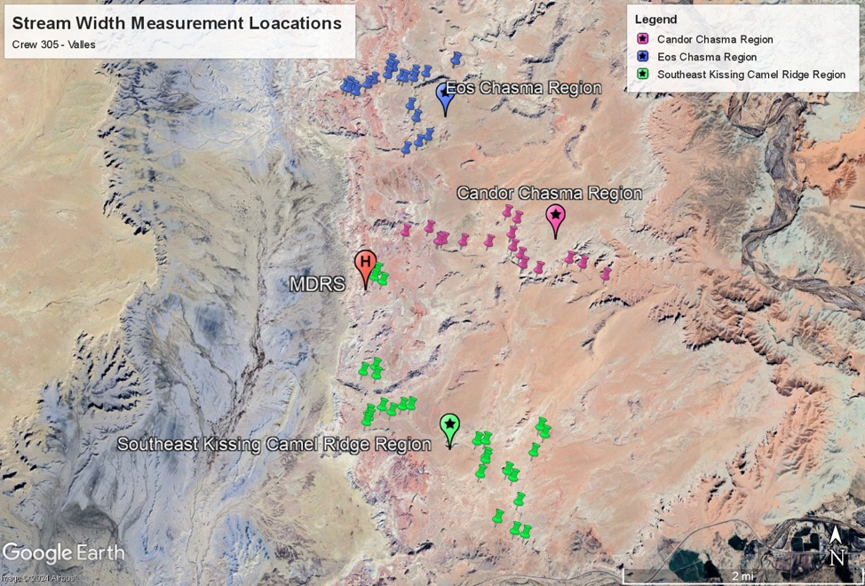

Figure 2. Satellite map of the three regions explored by Crew 305 – Valles: Candor Chasma (purple pins), Eos Chasma (blue pins), and Southeast of Kissing Camel Ridge (green pins).

**Summary of GreenHab Activities**

Crew GreenHab Officer: Hunter Vannier

It was a pleasure working in the GreenHab. During the mission, the cucumbers required twice-daily watering to prevent wilting. Many cucumbers have appeared over the past two weeks, though they are not mature enough to indulge in before our departure. The greatest change to the GreenHab was the transplanting and thinning of tomatoes. Two raised beds were refreshed and planted with six different types of microgreens. The crew was able to enjoy almost daily use of crops in meals. A soil moisture monitoring experiment was conducted during the Crew 305 stay.

**Science Summary**

We had 7 separate projects that covered a range of topics. Some of them were EVA-related, while others were conducted at MDRS campus. Overall, each project uniquely highlighted each crewmember’s strength and expertise, and expanded scientific, engineering, and human factor knowledge to support crewed exploration of Mars.

**Research Projects:**

**Title:** Hydraulic Geometry of Ephemeral Streams to Potentially Elucidate Paleoclimate

**Author:** Ian Pamerleau

**Description:** Ephemeral streams around MDRS carve out the landscape after heavy rain. The hydraulic geometry of these streams describes how the width and drainage area change as the flow moves up- to downstream. Hydraulic geometry relates to climate, lithology, and sediment load and is established for “mature” rivers with constantly flowing water. I will test if the ephemeral streams near MDRS hold the same hydraulic geometry in the literature, and what it elucidates about the climate.

We were able to thoroughly explore the three major drainage areas accessible to MDRS crews: Candor Chasma, Eos Chasma, and the region southeast of Kissing Camel Ridge (KCR) (Fig. 2). My objective was to take width measurements of branching tributaries and between said tributaries along a main channel because the drainage area of a channel will substantially increase when the area of another stream is added. We also took three measurements of the stream width at each location a meter or so apart from one another to get an average width of the location.

**Title:** Effect of Variable Soil Moisture on Microgreen Growth

**Author(s):** Hunter Vannier

**Description, activities, and results:** Efficient plant growth is an important element of life at MDRS and will be critical for sustainability if we want to create a self-sustaining presence on other planetary bodies. For this project, microgreens were watered at different volumes and the soil moisture content was monitored using a microcomputer and soil moisture sensors. Over the course of a week, the results were able to be applied to GreenHab microgreen growing practices, and water usage on these crops was improved by 20%.

*Figure 3: The soil moisture monitoring setup.*

**Title:** Sampling Paleosol Sequences for Mars Comparison

**Author(s):** Hunter Vannier

**Description, activities, and results:** The goal of this project was to collect samples from at least one exposed paleosol sequence with the intention of bringing it back to Purdue University for spectral and microscopic analyses. Paleosols have been proposed to have been observed on Mars via rover data, and little work has been done to understand their role in sedimentary recycling and retention of past water on the Mars surface. Three paleosol sequences were collected (15 total samples) that represent tens of millions of years of history in the MDRS region. The samples will be analyzed in the pursuit of improving our understanding of paleosols on Mars and their relationship to variable climates on Mars.

**Title:** Investigating Rover Applications in a Mars Analog Environment

**Author(s):** Spruha Vashi

**Description, activities, and results:** The objective of this work was to build a modular rover that can traverse the analog Mars terrain along with crew members on EVA. However, after multiple long days of group efforts at assembly and troubleshooting, the rover was unfortunately unable to start and be ready data collection. Data and observations were still collected to help understand applications of rovers in the analog environment, especially in scenarios where the rover would act as a member of the EVA team. Some main points of investigation were mobility, functionality, communications, teaming strategies, and future design. The observations made on EVAs clarify future design upgrades of the rover. Future observations of the rover in action working in a team of scientists can further identify failure and improvement points for teaming strategies of autonomous systems and astronauts in analog environments, the Moon, Mars, and beyond.

**Title:** MDRS Monitoring Overlay Sensors

**Author(s):** Monish Lokhande

**Description, activities, and results**:

**Description:** The project was focused on developing a network of Raspberry Pis to measure data from various locations in the habitat to measure the necessary sensor data (CO2, VOC, Air Quality, Temperature and Humidity).

**Activities:** A total of two sensor packs were developed inhouse were placed in Greenhab and Lower Hab to continuously monitor the temperature, humidity and CO2 levels. The sensor packs relay the information in the two different types of feeds: Local and Global. The local feed updates every minute to provide real-time data to the crew members in the habitat and can be used by the local crew members to monitor the health a certain location in the hab. Global feed is used as a transfer of necessary information to a remote ground station. The feed is designed in such a way that it considers the delays inherent in Mars-to-Earth communication. To limit the consumption of bandwidth, the global feed parses and sends only the necessary data at regular intervals. The continuous relay of data for global feed is done when there is a sensors which is not functioning or has faulty values.

Figure 4. Local Dashboard for sensor information

**Title:** Safety Lessons and Design Requirements on Autonomy for future Martian Habitats

**Author(s):** Rashi Jain

**Description, activities, and results**: I studied habitat design, operations, and system functionality to identify safety lessons and develop requirements for future Martian habitats. My objective was to analyse system interactions, pinpoint design weaknesses, and propose autonomous solutions for safe and resilient habitat operations.

For this, I documented and evaluated observations on all habitat modules like the Main Dome, Green Hab, Science Dome, Observatory, Tunnels, and the Airlock. This analysis informed functional relationships for systems such as power, extra-vehicular activity (EVA), and command, control, and communication. Figure 5 shows the functional relations for the power system. To this, I modelled performance variables, including solar irradiance and environmental factors, leading to sensor placement recommendations to improve autonomous monitoring.

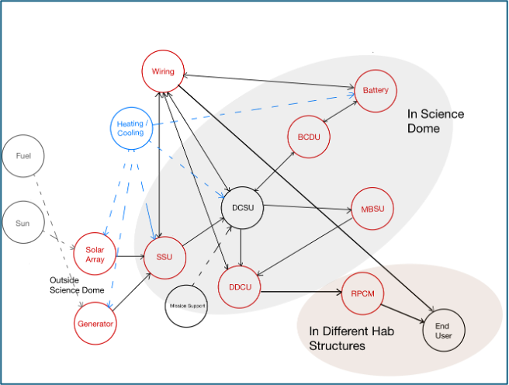

Figure 5. Power System Functional Diagram

Operational challenges included resource scarcity, inconsistent equipment performance, and reliance on manual problem-solving. Key safety lessons emphasized in-situ resource generation, solar power optimization, sensor accuracy, and robust backup systems. For example, non-functional solar batteries required reliance on a generator, highlighting the need for autonomous backups and better resource management.

I proposed autonomous design requirements, including power and environmental monitoring systems, automated state transitions, and redundant backup devices. Additionally, I recommended reorganizing storage and resources for operational efficiency.

Future work involves integrating functionality models into a digital simulation platform to test disruptions unique to Mars, such as radiation. This research provides actionable insights to enhance safety and sustainability for long-duration Martian missions.

**Title:** Wearable-Based Autonomic Activity Profiles for Real-Time Cognitive Performance Monitoring in Spaceflight

**Author(s):** Peter Zoss

**Description, activities, and results:** This study will longitudinally quantify individual changes in autonomic nervous system (ANS) status via a wearable sensor in MDRS crew members to understand how our autonomic activity is associated with sequential measures of cognitive performance for predictive model development. Baseline data from the wearable devices will also be used to look at changes while living in analog isolation. The activities planned to be completed at MDRS included cognitive performance testing. This testing was scheduled to take place every other day starting from Sol 1 for a total of 6 testing sessions for each of the crew members.

This human factor project was able to get through all of its data collection period at MDRS. Cognitive performance testing has been completed for all crew members for the planned 6 tests at the MDRS. These tests occurred on Sols 1, 3, 5, 7, 9 and 11. The tests on Sol 3 had to end early due to power failure, resulting in an incomplete test for one crew member and a missed test for another. The cognitive performance test used is called the Cognition Test Battery, and it was administered to the crew via an iPad. The results from this research will be looked at further back in West Lafayette where analysis can be completed.